**Encoder, Synthesizer and Vocoder Real‑Time Voice Cloning**

GitHub Link: <https://github.com/CorentinJ/Real-Time-Voice-Cloning>

1. **Install Anaconda & Python**
   * Download and install Anaconda (recommended Python 3.7–3.9).
   * Create a new environment:

conda create -n voiceclone python=3.9

conda activate voiceclone

conda install -c conda forge ffmpeg

1. **Install Dependencies**

* inflect==5.3.0
* librosa==0.8.1
* matplotlib==3.5.1
* numpy==1.20.3
* Pillow==8.4.0
* PyQt5==5.15.6
* scikit-learn==1.0.2
* scipy==1.7.3
* sounddevice==0.4.3
* SoundFile==0.10.3.post1
* tqdm==4.62.3
* umap-learn==0.5.2
* Unidecode==1.3.2
* urllib3==1.26.7
* visdom==0.1.8.9
* webrtcvad==2.0.10
* Use conda install -c conda-forge ffmpeg for audio encoding/decoding support.
* Install PyTorch

1. **Clone the Toolbox Repository**
   * Download the GitHub repo: https://github.com/CorentinJ/Real-Time-Voice-Cloning
   * Clone or unzip it to a local directory.
2. **Download Pre-trained Models**
   * Obtain encoder, synthesizer, and vocoder .pt files from the official release and place them in:

encoder/saved_models/pretrained.pt

synthesizer/saved_models/pretrained/pretrained.pt

vocoder/saved_models/pretrained/pretrained.pt

1. **Launch the Toolbox**
   * Run the demo:

cd Real-Time-Voice-Cloning

python demo_toolbox.py

1. **Uploading of Audio**

* The toolbox GUI allows:
  + Uploading or selecting a voice sample.
  + Entering custom text to synthesize.
  + Real-time cloning of one’s own voice or using provided samples.
* Synthesized speech generated via the loaded models.

1. We can test with LibriSpeech/train-clean-100

python demo_toolbox.py -d <datasets_root>

**Screenshots of Commands I used to run locally:**Encoder Training:

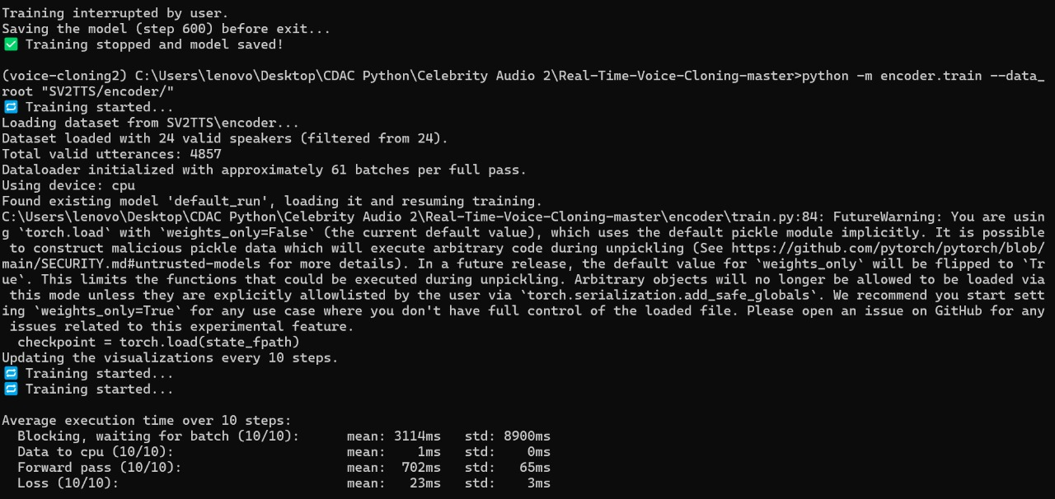

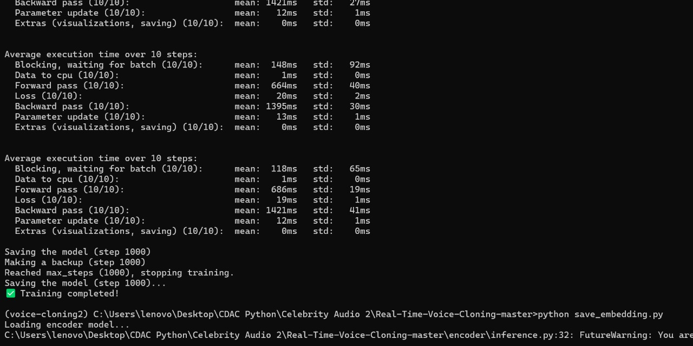

Encoder Inference:  
  
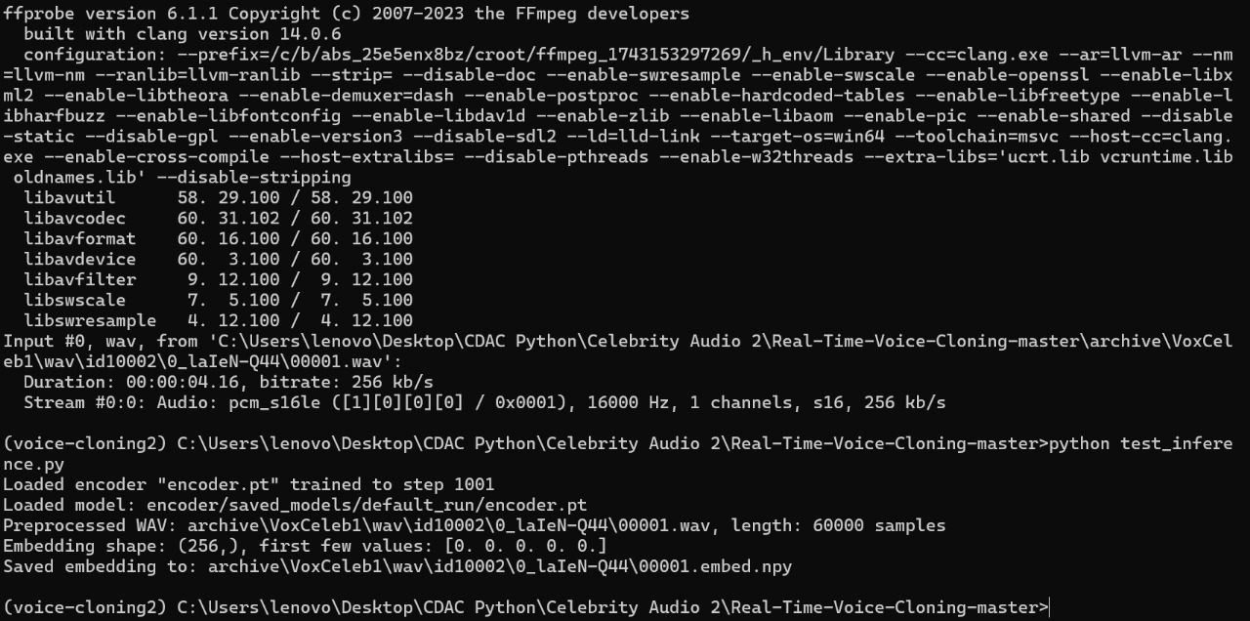

Encoder Indian Fine Tune:  
  
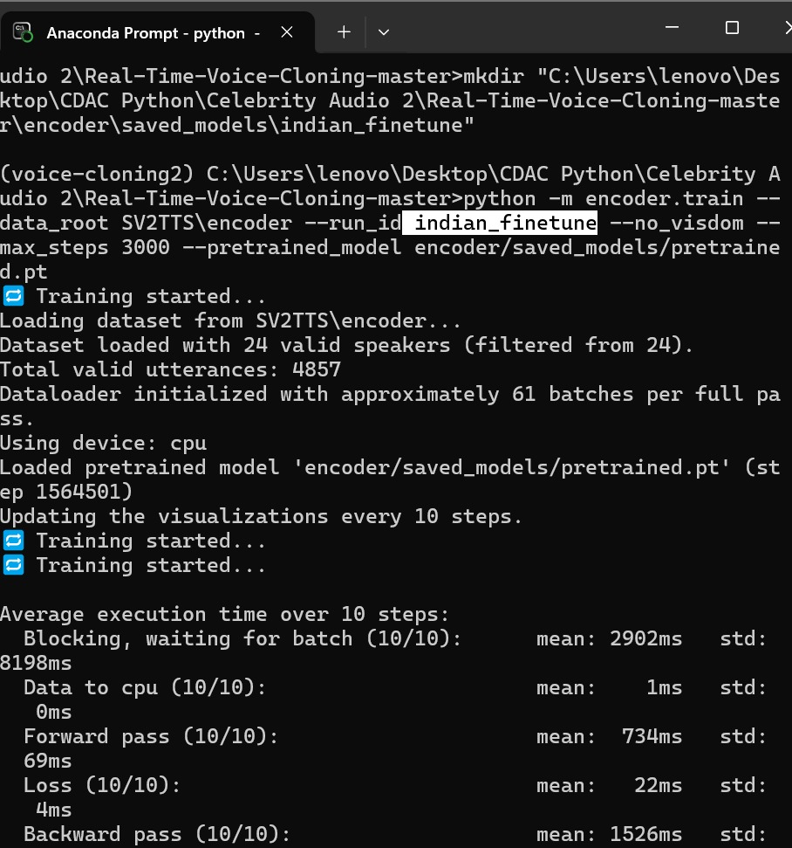

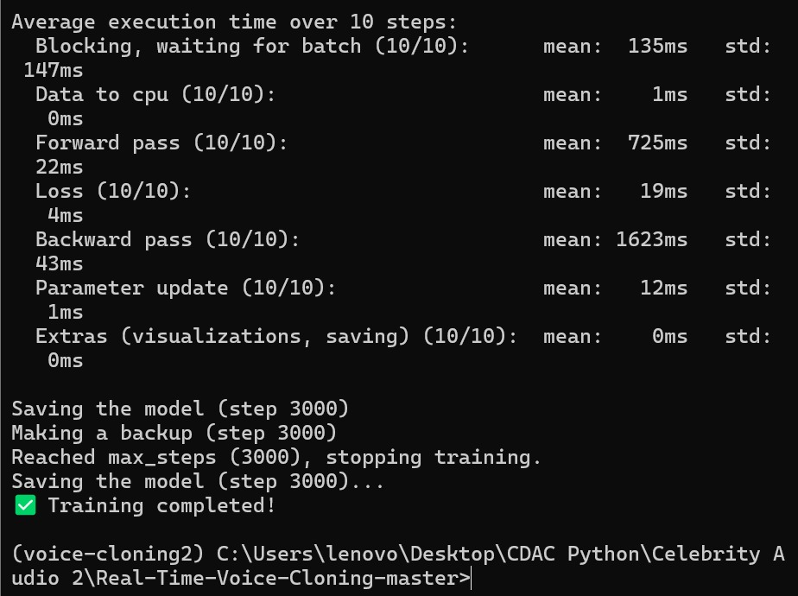

Encoder Final Inferencing:  
  
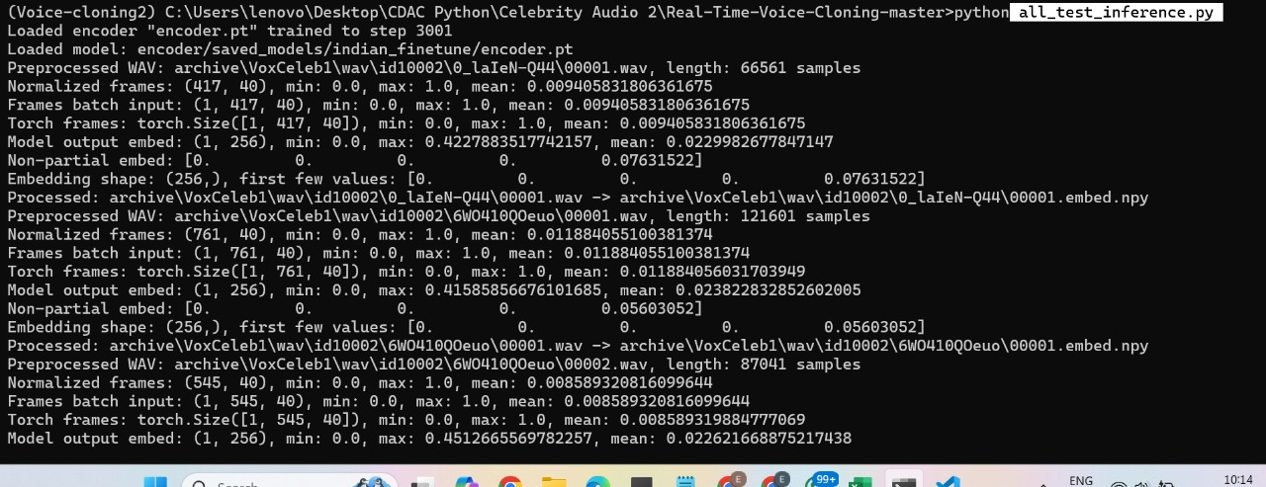  
  
Synthesizer Preprocessing:  
  
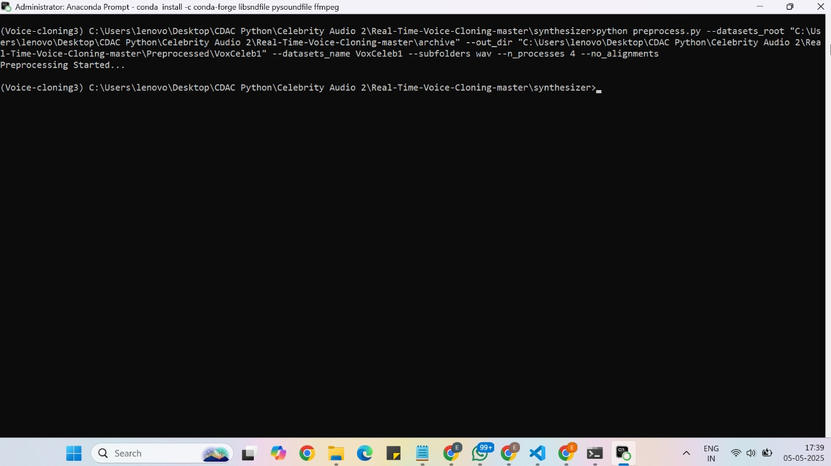

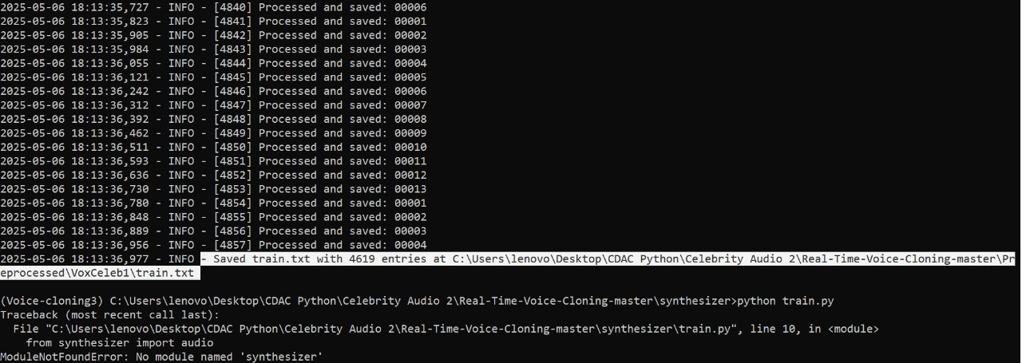

Synthesizer Training:  
  
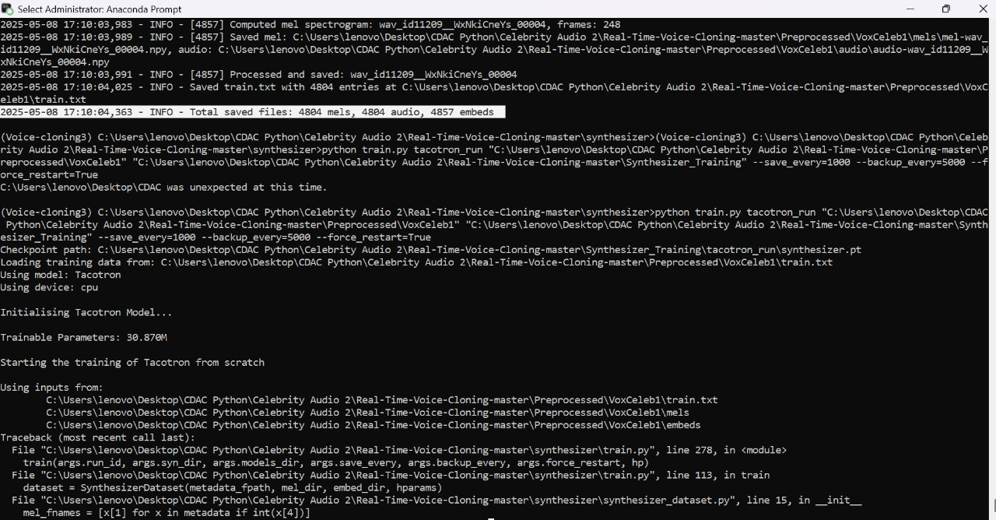

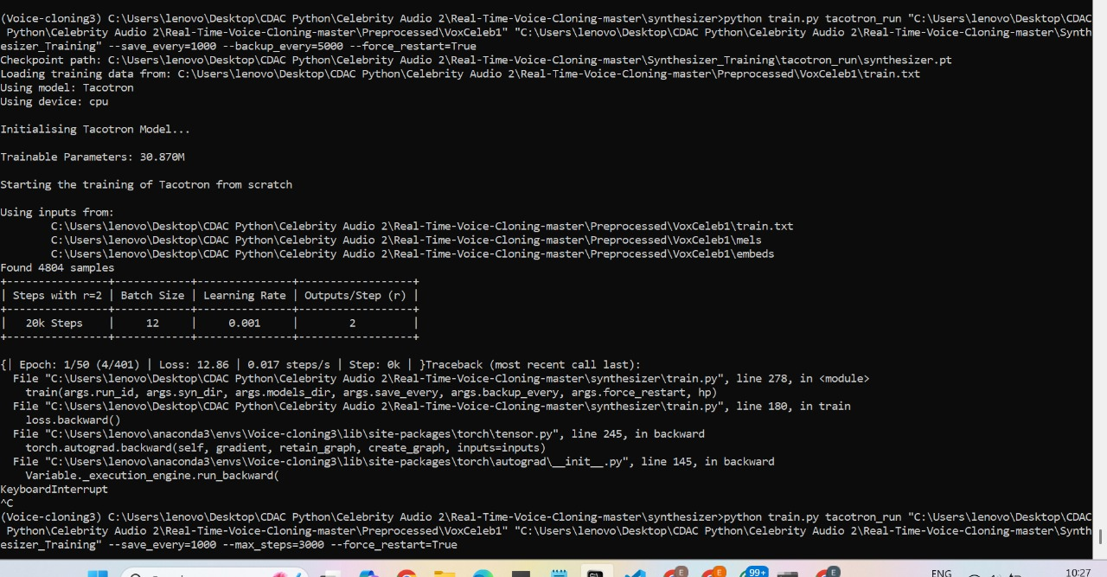

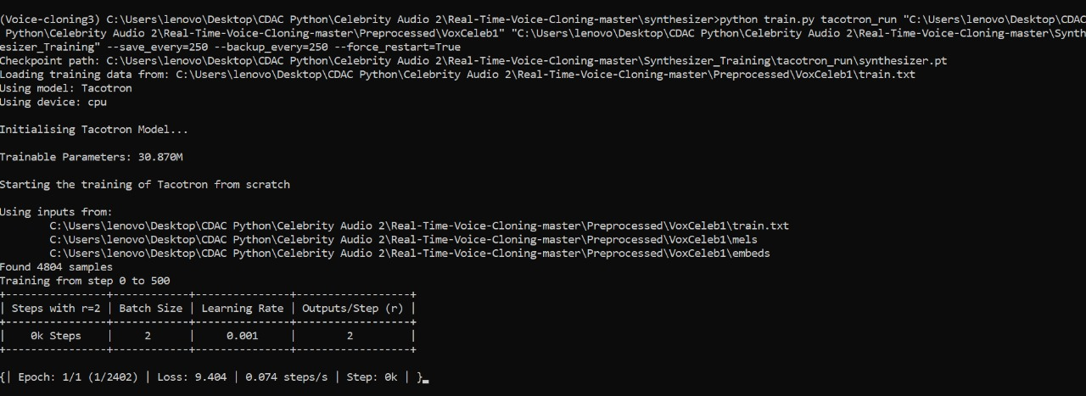

Synthesizer Inference:  
  
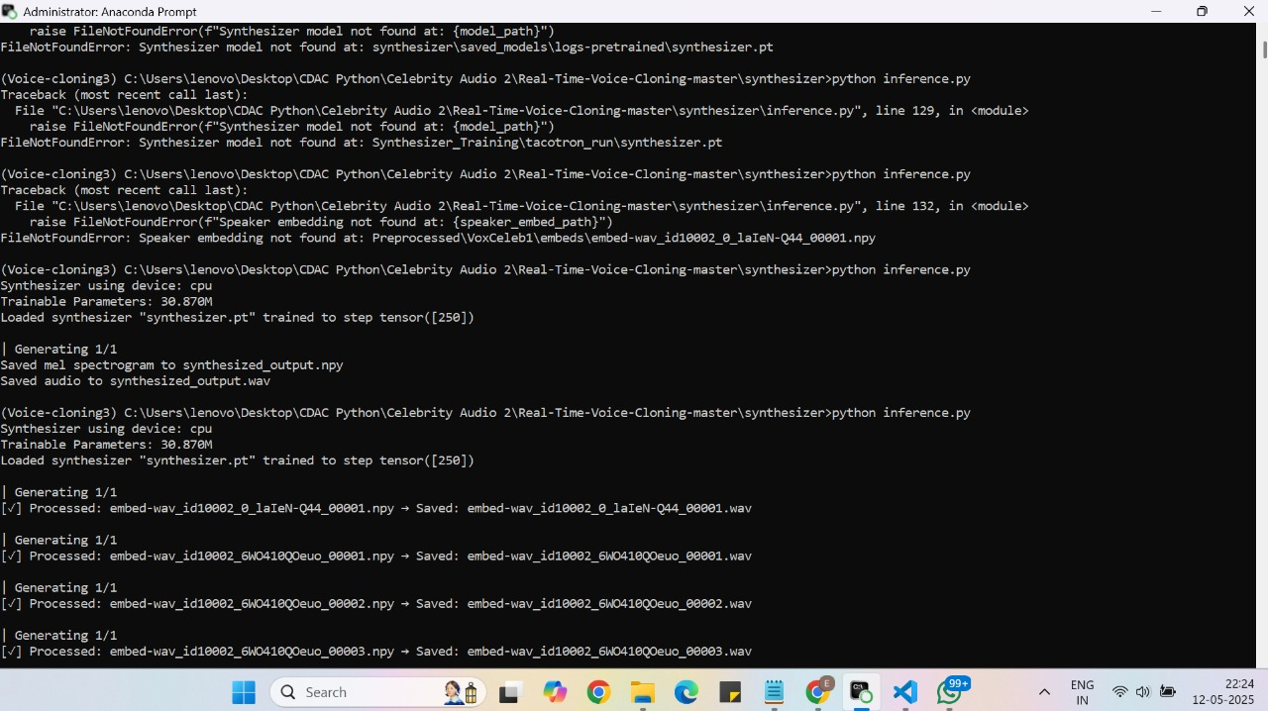

Vocoder Training:

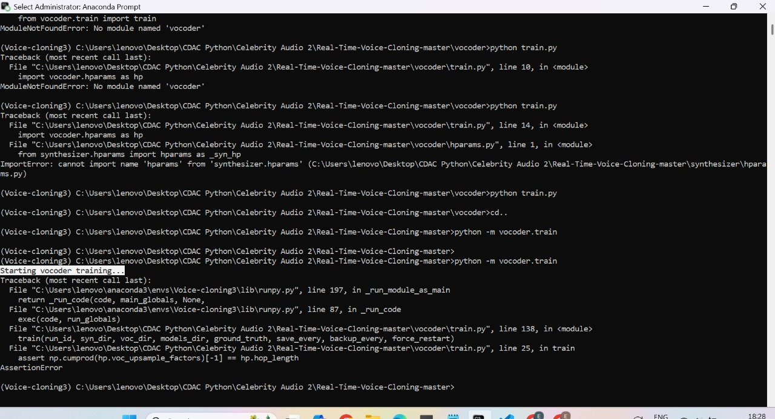

Running Synthesizer.py for vocoder training:  
  
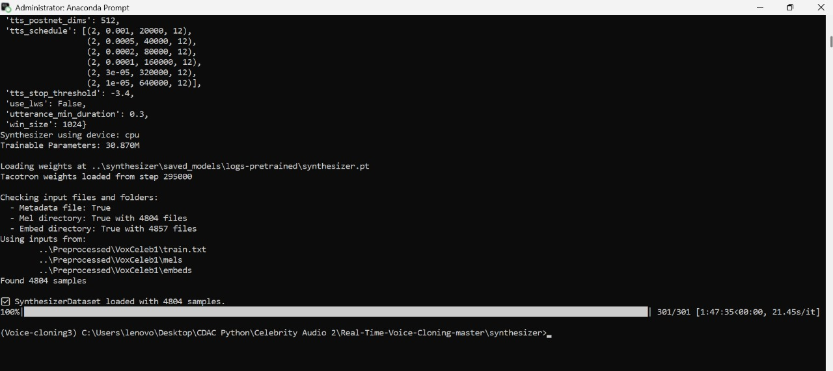

Vocoder training:  
  
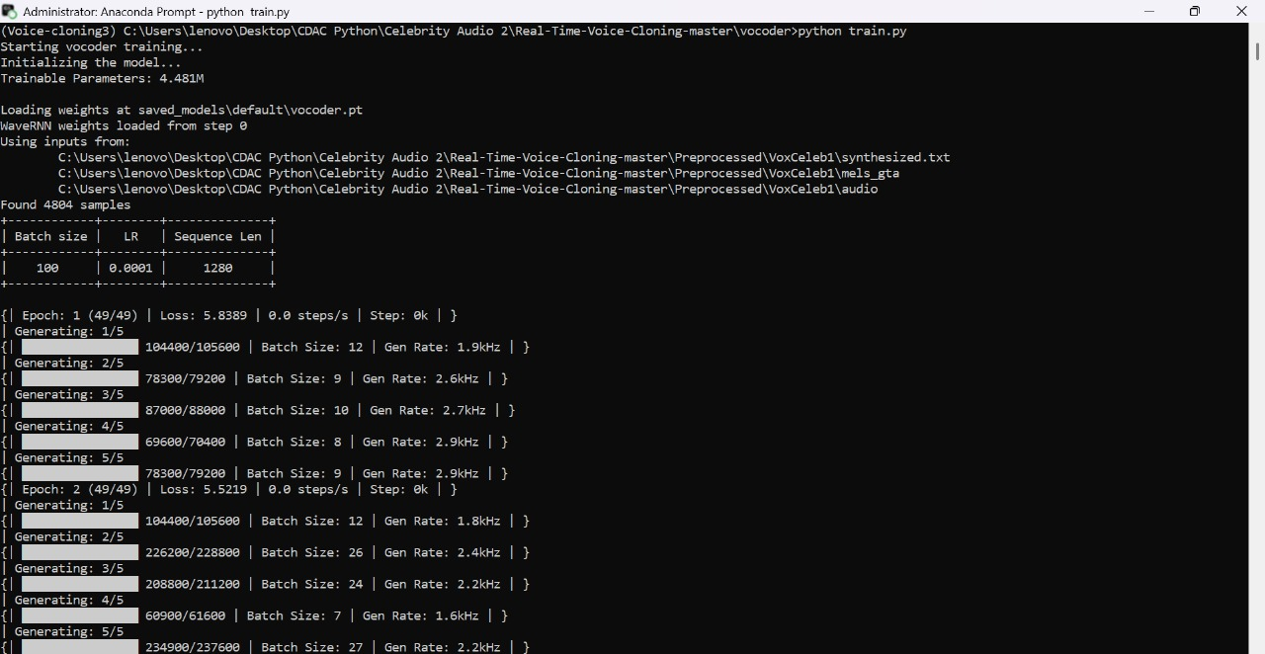

Vocoder sample voice plot for an audio:  
  
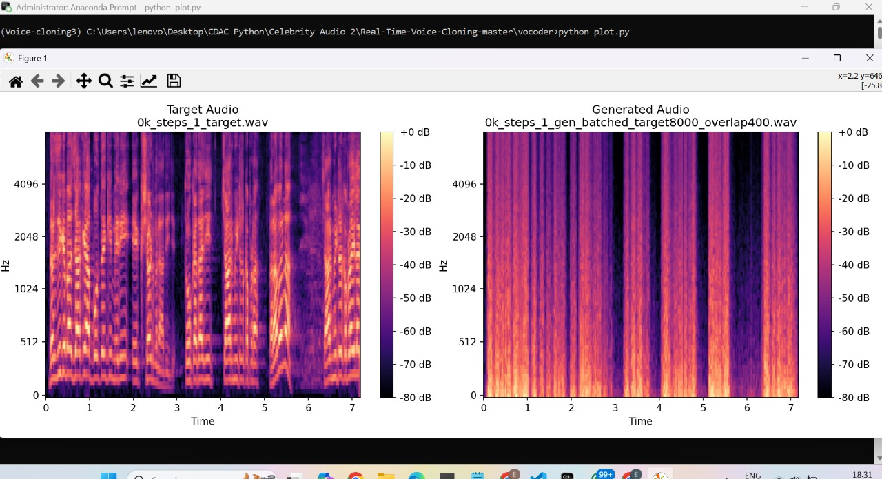  
  
Doing Encoder training in MOBAXTERM:  
  
python encoder_preprocess.py Audio_data --out_dir=Audio_data/SV2TTS/encoder/ -s true

python encoder_train.py encoder_run_1 Audio_data/SV2TTS/encoder/

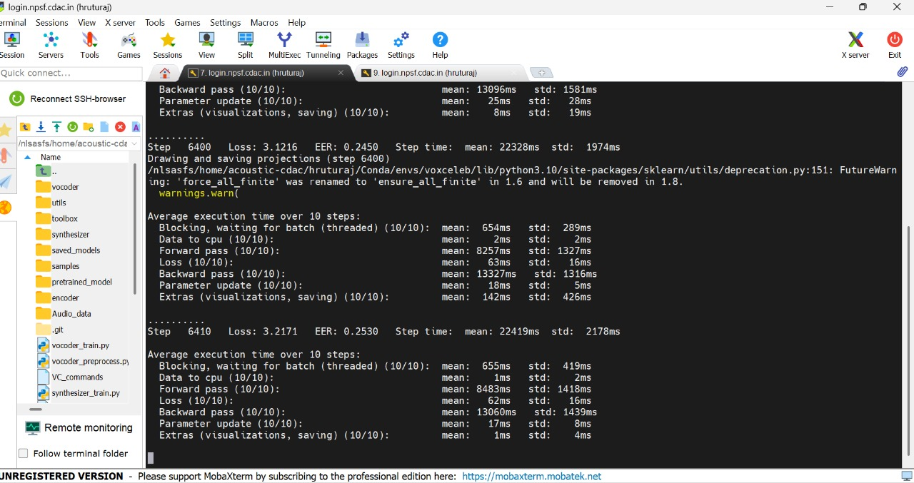

**Codes:  
Encoder:**

**Params_data.py**

hparams = {

    ## Mel-filterbank

    "mel_window_length": 25,  # In milliseconds

    "mel_window_step": 10,    # In milliseconds

    "mel_n_channels": 40,

    "num_mels": 40,

    ## Audio

    "sampling_rate": 16000,

    "partials_n_frames": 160,     # 1600 ms

    "inference_n_frames": 80,     #  800 ms

    ## Voice Activation Detection (VAD)

    "vad_window_length": 30,  # In milliseconds

    "vad_moving_average_width": 8,

    "vad_max_silence_length": 6,

    ## Audio volume normalization

    "audio_norm_target_dBFS": -30,

    ## Add these derived values 👇

    "fft_size": 512,

    "win_length": int(25 / 1000 * 16000),  # 25 ms window -> 400 samples

    "hop_length": int(10 / 1000 * 16000),  # 10 ms hop -> 160 samples

}

# Expose needed values for import

partials_n_frames = hparams["partials_n_frames"]

inference_n_frames = hparams["inference_n_frames"]

**Params_model.py**

## Model parameters

model_hidden_size = 256 #Size of hidden layers in the neural network.

model_embedding_size = 256 #Size of the output embedding vector representing speaker voice identity.

model_num_layers = 3

## Training parameters

learning_rate_init = 1e-4

speakers_per_batch = 64

utterances_per_speaker = 10

**config.py**  
  
librispeech_datasets = {

    "train": {

        "clean": ["LibriSpeech/train-clean-100", "LibriSpeech/train-clean-360"], #higher-quality recordings for training.

        "other": ["LibriSpeech/train-other-500"] #noisier or more challenging audio samples.

    },

    "test": {

        "clean": ["LibriSpeech/test-clean"],

        "other": ["LibriSpeech/test-other"]

    },

    "dev": { #used for validation during training.

        "clean": ["LibriSpeech/dev-clean"],

        "other": ["LibriSpeech/dev-other"]

    },

}

libritts_datasets = {

    "train": {

        "clean": ["LibriTTS/train-clean-100", "LibriTTS/train-clean-360"],

        "other": ["LibriTTS/train-other-500"]

    },

    "test": {

        "clean": ["LibriTTS/test-clean"],

        "other": ["LibriTTS/test-other"]

    },

    "dev": {

        "clean": ["LibriTTS/dev-clean"],

        "other": ["LibriTTS/dev-other"]

    },

}

voxceleb_datasets = {

    "voxceleb1" : {

        "train": ["VoxCeleb1/wav"],

        "test": ["VoxCeleb1/test_wav"]

    },

    "voxceleb2" : {

        "train": ["VoxCeleb2/dev/aac"],

        "test": ["VoxCeleb2/test_wav"]

    }

}

other_datasets = [

    "LJSpeech-1.1",

    "VCTK-Corpus/wav48",

]

anglophone_nationalites = ["australia", "canada", "ireland", "uk", "usa"]

**Audio.py**from scipy.ndimage.morphology import binary_dilation

from pathlib import Path

from typing import Optional, Union

from warnings import warn

import numpy as np

import librosa

import struct

try:

    import webrtcvad

except:

    warn("Unable to import 'webrtcvad'. This package enables noise removal and is recommended.")

    webrtcvad = None

int16_max = (2 ** 15) - 1

audio_norm_target_dBFS = -30

def preprocess_wav(fpath_or_wav: Union[str, Path, np.ndarray],

                   source_sr: Optional[int] = None,

                   normalize: Optional[bool] = True,

                   trim_silence: Optional[bool] = True,

                   hparams: dict = None):

    """

    Applies the preprocessing operations used in training the Speaker Encoder to a waveform

    either on disk or in memory. The waveform will be resampled to match the data hyperparameters.

    :param fpath_or_wav: either a filepath to an audio file (many extensions are supported, not

    just .wav), or the waveform as a numpy array of floats.

    :param source_sr: if passing an audio waveform, the sampling rate of the waveform before

    preprocessing. After preprocessing, the waveform's sampling rate will match the hparams.

    :param hparams: dictionary containing sampling_rate and other parameters.

    """

    if hparams is None:

        raise ValueError("hparams must be provided with sampling_rate defined.")

    # Load the wav from disk if needed

    if isinstance(fpath_or_wav, str) or isinstance(fpath_or_wav, Path):

        wav, source_sr = librosa.load(str(fpath_or_wav), sr=None)

    else:

        wav = fpath_or_wav

    # Resample the wav if needed

    if source_sr is not None and source_sr != hparams["sampling_rate"]:

        wav = librosa.resample(wav, source_sr, hparams["sampling_rate"])

    # Apply the preprocessing: normalize volume and shorten long silences

    if normalize:

        wav = normalize_volume(wav, audio_norm_target_dBFS, increase_only=True)

    if webrtcvad and trim_silence:

        wav = trim_long_silences(wav, hparams)

    return wav

def wav_to_mel_spectrogram(wav, hparams: dict):

    """

    Derives a mel spectrogram ready to be used by the encoder from a preprocessed audio waveform.

    Note: this is not a log-mel spectrogram.

    """

    frames = librosa.feature.melspectrogram(

        y=wav,

        sr=hparams["sampling_rate"],

        n_fft=hparams["fft_size"],

        hop_length=hparams["hop_length"],

        win_length=hparams["win_length"],

        n_mels=hparams["num_mels"]

    )

    return frames.astype(np.float32).T

def trim_long_silences(wav, hparams: dict):

    """

    Ensures that segments without voice in the waveform remain no longer than a

    threshold determined by the VAD parameters in hparams.

    :param wav: the raw waveform as a numpy array of floats

    :param hparams: dictionary containing VAD parameters and sampling_rate

    :return: the same waveform with silences trimmed away (length <= original wav length)

    """

    # Compute the voice detection window size

    samples_per_window = (hparams["vad_window_length"] * hparams["sampling_rate"]) // 1000

    # Trim the end of the audio to have a multiple of the window size

    wav = wav[:len(wav) - (len(wav) % samples_per_window)]

    # Convert the float waveform to 16-bit mono PCM

    pcm_wave = struct.pack("%dh" % len(wav), *(np.round(wav * int16_max)).astype(np.int16))

    # Perform voice activation detection

    voice_flags = []

    vad = webrtcvad.Vad(mode=3)

    for window_start in range(0, len(wav), samples_per_window):

        window_end = window_start + samples_per_window

        voice_flags.append(vad.is_speech(pcm_wave[window_start * 2:window_end * 2],

                                        sample_rate=hparams["sampling_rate"]))

    voice_flags = np.array(voice_flags)

    # Smooth the voice detection with a moving average

    def moving_average(array, width):

        array_padded = np.concatenate((np.zeros((width - 1) // 2), array, np.zeros(width // 2)))

        ret = np.cumsum(array_padded, dtype=float)

        ret[width:] = ret[width:] - ret[:-width]

        return ret[width - 1:] / width

    audio_mask = moving_average(voice_flags, hparams["vad_moving_average_width"])

    audio_mask = np.round(audio_mask).astype(np.bool_)

    # Dilate the voiced regions

    audio_mask = binary_dilation(audio_mask, np.ones(hparams["vad_max_silence_length"] + 1))

    audio_mask = np.repeat(audio_mask, samples_per_window)

    return wav[audio_mask == True]

def normalize_volume(wav, target_dBFS, increase_only=False, decrease_only=False):

    if increase_only and decrease_only:

        raise ValueError("Both increase only and decrease only are set")

    dBFS_change = target_dBFS - 10 * np.log10(np.mean(wav ** 2))

    if (dBFS_change < 0 and increase_only) or (dBFS_change > 0 and decrease_only):

        return wav

    return wav * (10 ** (dBFS_change / 20))

**Preprocess.py**

print("Starting preprocessing script...")

import sys

import os

sys.path.append(os.path.dirname(os.path.dirname(os.path.abspath(__file__))))

from datetime import datetime

from functools import partial

from multiprocessing import Pool

from pathlib import Path

import argparse

import numpy as np

from tqdm import tqdm

from encoder import audio

from encoder.config import librispeech_datasets, anglophone_nationalites

from encoder.params_data import hparams  # Import hparams directly

_AUDIO_EXTENSIONS = ("wav", "flac", "m4a", "mp3")

class DatasetLog:

    def __init__(self, root, name):

        self.text_file = open(Path(root, "Log_%s.txt" % name.replace("/", "_")), "w")

        self.sample_data = dict()

        start_time = str(datetime.now().strftime("%A %d %B %Y at %H:%M"))

        self.write_line("Creating dataset %s on %s" % (name, start_time))

        self.write_line("-----")

        self._log_params()

    def _log_params(self):

        self.write_line("Parameter values:")

        for param_name, value in hparams.items():

            self.write_line("\t%s: %s" % (param_name, value))

        self.write_line("-----")

    def write_line(self, line):

        self.text_file.write("%s\n" % line)

    def add_sample(self, **kwargs):

        for param_name, value in kwargs.items():

            if param_name not in self.sample_data:

                self.sample_data[param_name] = []

            self.sample_data[param_name].append(value)

    def finalize(self):

        self.write_line("Statistics:")

        for param_name, values in self.sample_data.items():

            self.write_line("\t%s:" % param_name)

            self.write_line("\t\tmin %.3f, max %.3f" % (np.min(values), np.max(values)))

            self.write_line("\t\tmean %.3f, median %.3f" % (np.mean(values), np.median(values)))

        self.write_line("-----")

        end_time = str(datetime.now().strftime("%A %d %B %Y at %H:%M"))

        self.write_line("Finished on %s" % end_time)

        self.text_file.close()

def _init_preprocess_dataset(dataset_name, datasets_root, out_dir) -> (Path, DatasetLog):

    dataset_root = datasets_root.joinpath(dataset_name)

    if not dataset_root.exists():

        print("Couldn\'t find %s, skipping this dataset." % dataset_root)

        return None, None

    return dataset_root, DatasetLog(out_dir, dataset_name)

def _preprocess_speaker(speaker_dir: Path, datasets_root: Path, out_dir: Path, skip_existing: bool):

    speaker_name = "_".join(speaker_dir.relative_to(datasets_root).parts)

    speaker_out_dir = out_dir.joinpath(speaker_name)

    speaker_out_dir.mkdir(exist_ok=True)

    sources_fpath = speaker_out_dir.joinpath("_sources.txt")

    if sources_fpath.exists():

        try:

            with sources_fpath.open("r") as sources_file:

                existing_fnames = {line.split(",")[0] for line in sources_file}

        except:

            existing_fnames = {}

    else:

        existing_fnames = {}

    sources_file = sources_fpath.open("a" if skip_existing else "w")

    audio_durs = []

    for extension in _AUDIO_EXTENSIONS:

        for yt_id_dir in speaker_dir.glob("*"):

            if not yt_id_dir.is_dir():

                continue

            for in_fpath in yt_id_dir.glob("**/*.%s" % extension):

                out_fname = "_".join(in_fpath.relative_to(speaker_dir).parts)

                out_fname = out_fname.replace(".%s" % extension, ".npy")

                if skip_existing and out_fname in existing_fnames:

                    continue

                # Pass hparams instead of sampling_rate

                wav = audio.preprocess_wav(in_fpath, hparams=hparams)

                if len(wav) == 0:

                    continue

                frames = audio.wav_to_mel_spectrogram(wav, hparams=hparams)

                if len(frames) < hparams["partials_n_frames"]:

                    continue

                out_fpath = speaker_out_dir.joinpath(out_fname)

                np.save(out_fpath, frames)

                sources_file.write("%s,%s\n" % (out_fname, in_fpath))

                audio_durs.append(len(wav) / hparams["sampling_rate"])

    sources_file.close()

    return audio_durs

def _preprocess_speaker_dirs(speaker_dirs, dataset_name, datasets_root, out_dir, skip_existing, logger, target_sampling_rate):

    print("%s: Preprocessing data for %d speakers with sampling rate %d Hz." % (dataset_name, len(speaker_dirs), target_sampling_rate))

    work_fn = partial(_preprocess_speaker, datasets_root=datasets_root, out_dir=out_dir, skip_existing=skip_existing)

    with Pool(4) as pool:

        tasks = pool.imap(work_fn, speaker_dirs)

        for sample_durs in tqdm(tasks, dataset_name, len(speaker_dirs), unit="speakers"):

            for sample_dur in sample_durs:

                logger.add_sample(duration=sample_dur)

    logger.finalize()

    print("Done preprocessing %s.\n" % dataset_name)

def preprocess_librispeech(datasets_root: Path, out_dir: Path, skip_existing=False, sampling_rate=16000):

    for dataset_name in librispeech_datasets["train"]["other"]:

        dataset_root, logger = _init_preprocess_dataset(dataset_name, datasets_root, out_dir)

        if not dataset_root:

            return

        speaker_dirs = list(dataset_root.glob("*"))

        _preprocess_speaker_dirs(speaker_dirs, dataset_name, datasets_root, out_dir, skip_existing, logger, sampling_rate)

def preprocess_voxceleb1(datasets_root: Path, out_dir: Path, skip_existing=False, sampling_rate=22050):

    dataset_name = "VoxCeleb1"

    dataset_root, logger = _init_preprocess_dataset(dataset_name, datasets_root, out_dir)

    if not dataset_root:

        return

    meta_file_path = dataset_root.joinpath("vox1_meta.csv")

    if meta_file_path.exists():

        with meta_file_path.open("r") as metafile:

            metadata = [line.split("\t") for line in metafile][1:]

            nationalities = {line[0]: line[3] for line in metadata}

            keep_speaker_ids = [speaker_id for speaker_id, nationality in nationalities.items() if

                                nationality.lower() in anglophone_nationalites]

            print("VoxCeleb1: using samples from %d (presumed anglophone) speakers out of %d." %

                  (len(keep_speaker_ids), len(nationalities)))

    else:

        print("VoxCeleb1: No meta file found, processing all speakers.")

        keep_speaker_ids = None

    wav_path = dataset_root.joinpath("wav")

    speaker_dirs = list(wav_path.glob("*"))

    if keep_speaker_ids:

        speaker_dirs = [d for d in speaker_dirs if d.name in keep_speaker_ids]

    print("VoxCeleb1: found %d speakers on the disk." % len(speaker_dirs))

    _preprocess_speaker_dirs(speaker_dirs, dataset_name, datasets_root, out_dir, skip_existing, logger, sampling_rate)

def preprocess_voxceleb2(datasets_root: Path, out_dir: Path, skip_existing=False, sampling_rate=16000):

    dataset_name = "VoxCeleb2"

    dataset_root, logger = _init_preprocess_dataset(dataset_name, datasets_root, out_dir)

    if not dataset_root:

        return

    speaker_dirs = list(dataset_root.joinpath("dev", "aac").glob("*"))

    _preprocess_speaker_dirs(speaker_dirs, dataset_name, datasets_root, out_dir, skip_existing, logger, sampling_rate)

if __name__ == "__main__":

    parser = argparse.ArgumentParser(description="Preprocesses audio files for encoder training.")

    parser.add_argument("datasets_root", type=str, help="Path to the dataset root")

    parser.add_argument("--datasets", type=str, nargs="+", default=["VoxCeleb1"], help="List of datasets to process")

    parser.add_argument("--sampling_rate", type=int, choices=[16000, 22050], default=22050, help="Target sampling rate (16000 or 22050 Hz)")

    parser.add_argument("--skip_existing", action="store_true", help="Skip existing processed files")

    parser.add_argument("--no_cuda", action="store_true", help="Disable CUDA")

    args = parser.parse_args()

    # Update hparams with the chosen sampling rate

    hparams["sampling_rate"] = args.sampling_rate

    hparams["win_length"] = int(hparams["mel_window_length"] / 1000 * args.sampling_rate)

    hparams["hop_length"] = int(hparams["mel_window_step"] / 1000 * args.sampling_rate)

    out_dir = Path("SV2TTS", "encoder")

    out_dir.mkdir(parents=True, exist_ok=True)

    for dataset in args.datasets:

        if dataset == "VoxCeleb1":

            preprocess_voxceleb1(Path(args.datasets_root), out_dir, args.skip_existing, args.sampling_rate)

        elif dataset == "VoxCeleb2":

            preprocess_voxceleb2(Path(args.datasets_root), out_dir, args.skip_existing, args.sampling_rate)

        elif dataset in librispeech_datasets["train"]["other"]:

            preprocess_librispeech(Path(args.datasets_root), out_dir, args.skip_existing, args.sampling_rate)

        else:

            print(f"Dataset {dataset} not recognized, skipping.")

**Model.py**from encoder.params_model import *

from encoder.params_data import *

from encoder.params_data import hparams

from scipy.interpolate import interp1d

from sklearn.metrics import roc_curve

from torch.nn.utils import clip_grad_norm_

from scipy.optimize import brentq

from torch import nn

import numpy as np

import torch

class SpeakerEncoder(nn.Module):

    def __init__(self, device, loss_device):

        super().__init__()

        self.loss_device = loss_device

        # Network defition

        self.lstm = nn.LSTM(input_size=hparams["mel_n_channels"],

                            hidden_size=model_hidden_size,

                            num_layers=model_num_layers,

                            batch_first=True).to(device)

        self.linear = nn.Linear(in_features=model_hidden_size,

                                out_features=model_embedding_size).to(device)

        self.relu = torch.nn.ReLU().to(device)

        # Cosine similarity scaling (with fixed initial parameter values)

        self.similarity_weight = nn.Parameter(torch.tensor([10.])).to(loss_device)

        self.similarity_bias = nn.Parameter(torch.tensor([-5.])).to(loss_device)

        # Loss

        self.loss_fn = nn.CrossEntropyLoss().to(loss_device)

    def do_gradient_ops(self):

        # Gradient scale

        self.similarity_weight.grad *= 0.01

        self.similarity_bias.grad *= 0.01

        # Gradient clipping

        clip_grad_norm_(self.parameters(), 3, norm_type=2)

    def forward(self, utterances, hidden_init=None):

        """

        Computes the embeddings of a batch of utterance spectrograms.

        :param utterances: batch of mel-scale filterbanks of same duration as a tensor of shape

        (batch_size, n_frames, n_channels)

        :param hidden_init: initial hidden state of the LSTM as a tensor of shape (num_layers,

        batch_size, hidden_size). Will default to a tensor of zeros if None.

        :return: the embeddings as a tensor of shape (batch_size, embedding_size)

        """

        # Pass the input through the LSTM layers and retrieve all outputs, the final hidden state

        # and the final cell state.

        out, (hidden, cell) = self.lstm(utterances, hidden_init)

        # We take only the hidden state of the last layer

        embeds_raw = self.relu(self.linear(hidden[-1]))

        # L2-normalize it

        embeds = embeds_raw / (torch.norm(embeds_raw, dim=1, keepdim=True) + 1e-5)

        return embeds

    def similarity_matrix(self, embeds):

        """

        Computes the similarity matrix according the section 2.1 of GE2E.

        :param embeds: the embeddings as a tensor of shape (speakers_per_batch,

        utterances_per_speaker, embedding_size)

        :return: the similarity matrix as a tensor of shape (speakers_per_batch,

        utterances_per_speaker, speakers_per_batch)

        """

        speakers_per_batch, utterances_per_speaker = embeds.shape[:2]

        # Inclusive centroids (1 per speaker). Cloning is needed for reverse differentiation

        centroids_incl = torch.mean(embeds, dim=1, keepdim=True)

        centroids_incl = centroids_incl.clone() / (torch.norm(centroids_incl, dim=2, keepdim=True) + 1e-5)

        # Exclusive centroids (1 per utterance)

        centroids_excl = (torch.sum(embeds, dim=1, keepdim=True) - embeds)

        centroids_excl /= (utterances_per_speaker - 1)

        centroids_excl = centroids_excl.clone() / (torch.norm(centroids_excl, dim=2, keepdim=True) + 1e-5)

        # Similarity matrix. The cosine similarity of already 2-normed vectors is simply the dot

        # product of these vectors (which is just an element-wise multiplication reduced by a sum).

        # We vectorize the computation for efficiency.

        sim_matrix = torch.zeros(speakers_per_batch, utterances_per_speaker,

                                 speakers_per_batch).to(self.loss_device)

        mask_matrix = 1 - np.eye(speakers_per_batch, dtype=np.int)

        for j in range(speakers_per_batch):

            mask = np.where(mask_matrix[j])[0]

            sim_matrix[mask, :, j] = (embeds[mask] * centroids_incl[j]).sum(dim=2)

            sim_matrix[j, :, j] = (embeds[j] * centroids_excl[j]).sum(dim=1)

        ## Even more vectorized version (slower maybe because of transpose)

        # sim_matrix2 = torch.zeros(speakers_per_batch, speakers_per_batch, utterances_per_speaker

        #                           ).to(self.loss_device)

        # eye = np.eye(speakers_per_batch, dtype=np.int)

        # mask = np.where(1 - eye)

        # sim_matrix2[mask] = (embeds[mask[0]] * centroids_incl[mask[1]]).sum(dim=2)

        # mask = np.where(eye)

        # sim_matrix2[mask] = (embeds * centroids_excl).sum(dim=2)

        # sim_matrix2 = sim_matrix2.transpose(1, 2)

        sim_matrix = sim_matrix * self.similarity_weight + self.similarity_bias

        return sim_matrix

    def loss(self, embeds):

        """

        Computes the softmax loss according the section 2.1 of GE2E.

        :param embeds: the embeddings as a tensor of shape (speakers_per_batch,

        utterances_per_speaker, embedding_size)

        :return: the loss and the EER for this batch of embeddings.

        """

        speakers_per_batch, utterances_per_speaker = embeds.shape[:2]

        # Loss

        sim_matrix = self.similarity_matrix(embeds)

        sim_matrix = sim_matrix.reshape((speakers_per_batch * utterances_per_speaker,

                                         speakers_per_batch))

        ground_truth = np.repeat(np.arange(speakers_per_batch), utterances_per_speaker)

        target = torch.from_numpy(ground_truth).long().to(self.loss_device)

        loss = self.loss_fn(sim_matrix, target)

        # EER (not backpropagated)

        with torch.no_grad():

            inv_argmax = lambda i: np.eye(1, speakers_per_batch, i, dtype=np.int)[0]

            labels = np.array([inv_argmax(i) for i in ground_truth])

            preds = sim_matrix.detach().cpu().numpy()

            # Snippet from https://yangcha.github.io/EER-ROC/

            fpr, tpr, thresholds = roc_curve(labels.flatten(), preds.flatten())

            eer = brentq(lambda x: 1. - x - interp1d(fpr, tpr)(x), 0., 1.)

        return loss, eer

**Train.py**from pathlib import Path

import argparse

import os

import torch

from encoder.data_objects import SpeakerVerificationDataLoader, SpeakerVerificationDataset

from encoder.model import SpeakerEncoder

from encoder.params_model import *

from encoder.visualizations import Visualizations

from utils.profiler import Profiler

# Print only from the main process

if os.environ.get('RANK', '0') == '0':

    print("🔁 Training started...")

def sync(device: torch.device):

    if device.type == "cuda":

        torch.cuda.synchronize(device)

def train(run_id: str, clean_data_root: Path, models_dir: Path, umap_every: int, save_every: int,

          backup_every: int, vis_every: int, force_restart: bool, visdom_server: str,

          no_visdom: bool, max_steps: int, pretrained_model: str):

    main_process = os.environ.get('RANK', '0') == '0'

    if main_process:

        print(f"Loading dataset from {clean_data_root}...")

    # Create dataset and filter speakers

    try:

        dataset = SpeakerVerificationDataset(clean_data_root)

        speaker_dirs = [d for d in clean_data_root.iterdir() if d.is_dir()]

        speaker_utterances = {d.name: len(list(d.glob("*.npy"))) for d in speaker_dirs}

        min_utterances = 5

        valid_speakers = [s for s, count in speaker_utterances.items() if count >= min_utterances]

        dataset.speakers = valid_speakers

        if not valid_speakers:

            if main_process:

                print(f"No speakers found with at least {min_utterances} utterances. Training aborted.")

            return

        total_utterances = sum(speaker_utterances[s] for s in valid_speakers)

        if main_process:

            print(f"Dataset loaded with {len(valid_speakers)} valid speakers (filtered from {len(speaker_dirs)}).")

            print(f"Total valid utterances: {total_utterances}")

    except Exception as e:

        if main_process:

            print(f"Failed to load dataset: {e}")

        return

    # Adjust batch sizes

    speakers_per_batch = min(16, len(valid_speakers))

    utterances_per_speaker = 5

    loader = SpeakerVerificationDataLoader(

        dataset,

        speakers_per_batch=speakers_per_batch,

        utterances_per_speaker=utterances_per_speaker,

        num_workers=2,

    )

    if main_process:

        num_batches = (total_utterances + speakers_per_batch * utterances_per_speaker - 1) // (speakers_per_batch * utterances_per_speaker)

        print(f"Dataloader initialized with approximately {num_batches} batches per full pass.")

    # Setup device

    device = torch.device("cuda" if torch.cuda.is_available() else "cpu")

    loss_device = torch.device("cpu")

    if main_process:

        print(f"Using device: {device}")

    # Create model and optimizer

    model = SpeakerEncoder(device, loss_device)

    optimizer = torch.optim.Adam(model.parameters(), lr=learning_rate_init)

    init_step = 1

    # Load pretrained model if specified

    state_fpath = models_dir / run_id / "encoder.pt"

    if pretrained_model:

        checkpoint = torch.load(pretrained_model, map_location=device, weights_only=True)

        model.load_state_dict(checkpoint["model_state"])

        init_step = 1

        if main_process:

            print(f"Loaded pretrained model '{pretrained_model}' (step {checkpoint['step']})")

    elif not force_restart and state_fpath.exists():

        if main_process:

            print(f"Found existing model '{run_id}', loading it and resuming training.")

        checkpoint = torch.load(state_fpath)

        init_step = checkpoint["step"]

        model.load_state_dict(checkpoint["model_state"])

        optimizer.load_state_dict(checkpoint["optimizer_state"])

        optimizer.param_groups[0]["lr"] = learning_rate_init

    else:

        if main_process:

            print(f"No model '{run_id}' found or force_restart is True, starting from scratch.")

    model.train()

    # Initialize visualizations

    vis = Visualizations(run_id, vis_every, server=visdom_server, disabled=no_visdom)

    if not no_visdom and main_process:

        vis.log_dataset(dataset)

        vis.log_params()

        device_name = str(torch.cuda.get_device_name(0) if torch.cuda.is_available() else "CPU")

        vis.log_implementation({"Device": device_name})

    # Training loop

    profiler = Profiler(summarize_every=10, disabled=False)

    try:

        for step, speaker_batch in enumerate(loader, init_step):

            if step > max_steps:

                if main_process:

                    print(f"Reached max_steps ({max_steps}), stopping training.")

                    print(f"Saving the model (step {step - 1})...")

                    torch.save({

                        "step": step,

                        "model_state": model.state_dict(),

                        "optimizer_state": optimizer.state_dict(),

                    }, state_fpath)

                break

            profiler.tick("Blocking, waiting for batch")

            # Forward pass

            inputs = torch.from_numpy(speaker_batch.data).to(device)

            sync(device)

            profiler.tick("Data to %s" % device)

            embeds = model(inputs)

            sync(device)

            profiler.tick("Forward pass")

            embeds_loss = embeds.view((speakers_per_batch, utterances_per_speaker, -1)).to(loss_device)

            loss, eer = model.loss(embeds_loss)

            sync(loss_device)

            profiler.tick("Loss")

            # Backward pass

            model.zero_grad()

            loss.backward()

            profiler.tick("Backward pass")

            model.do_gradient_ops()

            optimizer.step()

            profiler.tick("Parameter update")

            # Update visualizations

            if not no_visdom and main_process:

                vis.update(loss.item(), eer, step)

                if umap_every != 0 and step % umap_every == 0:

                    print(f"Drawing and saving projections (step {step})")

                    projection_fpath = models_dir / run_id / f"umap_{step:06d}.png"

                    embeds = embeds.detach().cpu().numpy()

                    vis.draw_projections(embeds, utterances_per_speaker, step, projection_fpath)

                    vis.save()

            # Save model

            if save_every != 0 and step % save_every == 0 and main_process:

                print(f"Saving the model (step {step})")

                torch.save({

                    "step": step + 1,

                    "model_state": model.state_dict(),

                    "optimizer_state": optimizer.state_dict(),

                }, state_fpath)

            # Backup

            if backup_every != 0 and step % backup_every == 0 and main_process:

                print(f"Making a backup (step {step})")

                backup_fpath = models_dir / run_id / f"encoder_{step:06d}.bak"

                torch.save({

                    "step": step + 1,

                    "model_state": model.state_dict(),

                    "optimizer_state": optimizer.state_dict(),

                }, backup_fpath)

            profiler.tick("Extras (visualizations, saving)")

        if main_process and step <= max_steps:

            print("✅ Training completed (reached end of data before max_steps)!")

            print(f"Saving final model (step {step})...")

            torch.save({

                "step": step + 1,

                "model_state": model.state_dict(),

                "optimizer_state": optimizer.state_dict(),

            }, state_fpath)

    except KeyboardInterrupt:

        if main_process:

            print("\nTraining interrupted by user.")

            print(f"Saving the model (step {step}) before exit...")

            torch.save({

                "step": step + 1,

                "model_state": model.state_dict(),

                "optimizer_state": optimizer.state_dict(),

            }, state_fpath)

            print("✅ Training stopped and model saved!")

    if main_process:

        print("✅ Training completed!")

if __name__ == "__main__":

    parser = argparse.ArgumentParser(description="Trains the speaker encoder.")

    parser.add_argument("--data_root", type=str, required=True, help="Path to preprocessed data")

    parser.add_argument("--run_id", type=str, default="default_run", help="Run identifier")

    parser.add_argument("--models_dir", type=Path, default=Path("encoder/saved_models"), help="Directory for saved models")

    parser.add_argument("--umap_every", type=int, default=10, help="Steps between UMAP projections")

    parser.add_argument("--save_every", type=int, default=100, help="Steps between model saves")

    parser.add_argument("--backup_every", type=int, default=500, help="Steps between backups")

    parser.add_argument("--vis_every", type=int, default=10, help="Steps between visualization updates")

    parser.add_argument("--force_restart", action="store_true", help="Force training from scratch")

    parser.add_argument("--visdom_server", type=str, default="http://localhost", help="Visdom server address")

    parser.add_argument("--no_visdom", action="store_true", help="Disable Visdom visualizations", default=True)

    parser.add_argument("--max_steps", type=int, default=3000, help="Maximum training steps")

    parser.add_argument("--pretrained_model", type=str, default=None, help="Path to pretrained model for fine-tuning")

    args = parser.parse_args()

    train(

        run_id=args.run_id,

        clean_data_root=Path(args.data_root),

        models_dir=args.models_dir,

        umap_every=args.umap_every,

        save_every=args.save_every,

        backup_every=args.backup_every,

        vis_every=args.vis_every,

        force_restart=args.force_restart,

        visdom_server=args.visdom_server,

        no_visdom=args.no_visdom,

        max_steps=args.max_steps,

        pretrained_model=args.pretrained_model

    )

**Synthesizer:  
  
Hparams.py**

import ast

import pprint

class HParams(object):

    def __init__(self, **kwargs): self.__dict__.update(kwargs)

    def __setitem__(self, key, value): setattr(self, key, value)

    def __getitem__(self, key): return getattr(self, key)

    def __repr__(self): return pprint.pformat(self.__dict__)

    def parse(self, string):

        # Overrides hparams from a comma-separated string of name=value pairs

        if len(string) > 0:

            overrides = [s.split("=") for s in string.split(",")]

            keys, values = zip(*overrides)

            keys = list(map(str.strip, keys))

            values = list(map(str.strip, values))

            for k in keys:

                self.__dict__[k] = ast.literal_eval(values[keys.index(k)])

        return self

hparams = HParams(

        ### Signal Processing (used in both synthesizer and vocoder)

        sample_rate = 16000,

        n_fft = 800,

        num_mels = 80,

        hop_size = 200,                             # Tacotron uses 12.5 ms frame shift (set to sample_rate * 0.0125)

        win_size = 800,                             # Tacotron uses 50 ms frame length (set to sample_rate * 0.050)

        fmin = 55,

        min_level_db = -100,

        ref_level_db = 20,

        max_abs_value = 4.,                         # Gradient explodes if too big, premature convergence if too small.

        preemphasis = 0.97,                         # Filter coefficient to use if preemphasize is True

        preemphasize = True,

        ### Tacotron Text-to-Speech (TTS)

        tts_embed_dims = 512,                       # Embedding dimension for the graphemes/phoneme inputs

        tts_encoder_dims = 256,

        tts_decoder_dims = 128,

        tts_postnet_dims = 512,

        tts_encoder_K = 5,

        tts_lstm_dims = 1024,

        tts_postnet_K = 5,

        tts_num_highways = 4,

        tts_dropout = 0.5,

        tts_cleaner_names = ["english_cleaners"],

        tts_stop_threshold = -3.4,                  # Value below which audio generation ends.

                                                    # For example, for a range of [-4, 4], this

                                                    # will terminate the sequence at the first

                                                    # frame that has all values < -3.4

        ### Tacotron Training

        tts_schedule = [(2,  1e-3,  20_000,  12),   # Progressive training schedule

                        (2,  5e-4,  40_000,  12),   # (r, lr, step, batch_size)

                        (2,  2e-4,  80_000,  12),   #

                        (2,  1e-4, 160_000,  12),   # r = reduction factor (# of mel frames

                        (2,  3e-5, 320_000,  12),   #     synthesized for each decoder iteration)

                        (2,  1e-5, 640_000,  12)],  # lr = learning rate

        tts_clip_grad_norm = 1.0,                   # clips the gradient norm to prevent explosion - set to None if not needed

        tts_eval_interval = 500,                    # Number of steps between model evaluation (sample generation)

                                                    # Set to -1 to generate after completing epoch, or 0 to disable

        tts_eval_num_samples = 1,                   # Makes this number of samples

        ### Data Preprocessing

        max_mel_frames = 900,

        rescale = True,

        rescaling_max = 0.9,

        synthesis_batch_size = 16,                  # For vocoder preprocessing and inference.

        ### Mel Visualization and Griffin-Lim

        signal_normalization = True,

        power = 1.5,

        griffin_lim_iters = 60,

        ### Audio processing options

        fmax = 7600,                                # Should not exceed (sample_rate // 2)

        allow_clipping_in_normalization = True,     # Used when signal_normalization = True

        clip_mels_length = True,                    # If true, discards samples exceeding max_mel_frames

        use_lws = False,                            # "Fast spectrogram phase recovery using local weighted sums"

        symmetric_mels = True,                      # Sets mel range to [-max_abs_value, max_abs_value] if True,

                                                    #               and [0, max_abs_value] if False

        trim_silence = True,                        # Use with sample_rate of 16000 for best results

        ### SV2TTS

        speaker_embedding_size = 256,               # Dimension for the speaker embedding

        silence_min_duration_split = 0.4,           # Duration in seconds of a silence for an utterance to be split

        utterance_min_duration = 1.6,               # Duration in seconds below which utterances are discarded

        )

def hparams_debug_string():

    return str(hparams)

**Audio.py**

import librosa

import librosa.filters

import numpy as np

from scipy import signal

from scipy.io import wavfile

import soundfile as sf

def load_wav(path, sr):

    return librosa.core.load(path, sr=sr)[0]

def save_wav(wav, path, sr):

    wav *= 32767 / max(0.01, np.max(np.abs(wav)))

    #proposed by @dsmiller

    wavfile.write(path, sr, wav.astype(np.int16))

def save_wavenet_wav(wav, path, sr):

    sf.write(path, wav.astype(np.float32), sr)

def preemphasis(wav, k, preemphasize=True):

    if preemphasize:

        return signal.lfilter([1, -k], [1], wav)

    return wav

def inv_preemphasis(wav, k, inv_preemphasize=True):

    if inv_preemphasize:

        return signal.lfilter([1], [1, -k], wav)

    return wav

#From https://github.com/r9y9/wavenet_vocoder/blob/master/audio.py

def start_and_end_indices(quantized, silence_threshold=2):

    for start in range(quantized.size):

        if abs(quantized[start] - 127) > silence_threshold:

            break

    for end in range(quantized.size - 1, 1, -1):

        if abs(quantized[end] - 127) > silence_threshold:

            break

    assert abs(quantized[start] - 127) > silence_threshold

    assert abs(quantized[end] - 127) > silence_threshold

    return start, end

def get_hop_size(hparams):

    hop_size = hparams.hop_size

    if hop_size is None:

        assert hparams.frame_shift_ms is not None

        hop_size = int(hparams.frame_shift_ms / 1000 * hparams.sample_rate)

    return hop_size

def linearspectrogram(wav, hparams):

    D = _stft(preemphasis(wav, hparams.preemphasis, hparams.preemphasize), hparams)

    S = _amp_to_db(np.abs(D), hparams) - hparams.ref_level_db

    if hparams.signal_normalization:

        return _normalize(S, hparams)

    return S

def melspectrogram(wav, hparams):

    D = _stft(preemphasis(wav, hparams.preemphasis, hparams.preemphasize), hparams)

    S = _amp_to_db(_linear_to_mel(np.abs(D), hparams), hparams) - hparams.ref_level_db

    if hparams.signal_normalization:

        return _normalize(S, hparams)

    return S

def inv_linear_spectrogram(linear_spectrogram, hparams):

    """Converts linear spectrogram to waveform using librosa"""

    if hparams.signal_normalization:

        D = _denormalize(linear_spectrogram, hparams)

    else:

        D = linear_spectrogram

    S = _db_to_amp(D + hparams.ref_level_db) #Convert back to linear

    if hparams.use_lws:

        processor = _lws_processor(hparams)

        D = processor.run_lws(S.astype(np.float64).T ** hparams.power)

        y = processor.istft(D).astype(np.float32)

        return inv_preemphasis(y, hparams.preemphasis, hparams.preemphasize)

    else:

        return inv_preemphasis(_griffin_lim(S ** hparams.power, hparams), hparams.preemphasis, hparams.preemphasize)

def inv_mel_spectrogram(mel_spectrogram, hparams):

    """Converts mel spectrogram to waveform using librosa"""

    if hparams.signal_normalization:

        D = _denormalize(mel_spectrogram, hparams)

    else:

        D = mel_spectrogram

    S = _mel_to_linear(_db_to_amp(D + hparams.ref_level_db), hparams)  # Convert back to linear

    if hparams.use_lws:

        processor = _lws_processor(hparams)

        D = processor.run_lws(S.astype(np.float64).T ** hparams.power)

        y = processor.istft(D).astype(np.float32)

        return inv_preemphasis(y, hparams.preemphasis, hparams.preemphasize)

    else:

        return inv_preemphasis(_griffin_lim(S ** hparams.power, hparams), hparams.preemphasis, hparams.preemphasize)

def _lws_processor(hparams):

    import lws

    return lws.lws(hparams.n_fft, get_hop_size(hparams), fftsize=hparams.win_size, mode="speech")

def _griffin_lim(S, hparams):

    """librosa implementation of Griffin-Lim

    Based on https://github.com/librosa/librosa/issues/434

    """

    angles = np.exp(2j * np.pi * np.random.rand(*S.shape))

    S_complex = np.abs(S).astype(np.complex)

    y = _istft(S_complex * angles, hparams)

    for i in range(hparams.griffin_lim_iters):

        angles = np.exp(1j * np.angle(_stft(y, hparams)))

        y = _istft(S_complex * angles, hparams)

    return y

def _stft(y, hparams):

    if hparams.use_lws:

        return _lws_processor(hparams).stft(y).T

    else:

        return librosa.stft(y=y, n_fft=hparams.n_fft, hop_length=get_hop_size(hparams), win_length=hparams.win_size)

def _istft(y, hparams):

    return librosa.istft(y, hop_length=get_hop_size(hparams), win_length=hparams.win_size)

##########################################################

#Those are only correct when using lws!!! (This was messing with Wavenet quality for a long time!)

def num_frames(length, fsize, fshift):

    """Compute number of time frames of spectrogram

    """

    pad = (fsize - fshift)

    if length % fshift == 0:

        M = (length + pad * 2 - fsize) // fshift + 1

    else:

        M = (length + pad * 2 - fsize) // fshift + 2

    return M

def pad_lr(x, fsize, fshift):

    """Compute left and right padding

    """

    M = num_frames(len(x), fsize, fshift)

    pad = (fsize - fshift)

    T = len(x) + 2 * pad

    r = (M - 1) * fshift + fsize - T

    return pad, pad + r

##########################################################

#Librosa correct padding

def librosa_pad_lr(x, fsize, fshift):

    return 0, (x.shape[0] // fshift + 1) * fshift - x.shape[0]

# Conversions

_mel_basis = None

_inv_mel_basis = None

def _linear_to_mel(spectogram, hparams):

    global _mel_basis

    if _mel_basis is None:

        _mel_basis = _build_mel_basis(hparams)

    return np.dot(_mel_basis, spectogram)

def _mel_to_linear(mel_spectrogram, hparams):

    global _inv_mel_basis

    if _inv_mel_basis is None:

        _inv_mel_basis = np.linalg.pinv(_build_mel_basis(hparams))

    return np.maximum(1e-10, np.dot(_inv_mel_basis, mel_spectrogram))

def _build_mel_basis(hparams):

    assert hparams.fmax <= hparams.sample_rate // 2

    return librosa.filters.mel(hparams.sample_rate, hparams.n_fft, n_mels=hparams.num_mels,

                               fmin=hparams.fmin, fmax=hparams.fmax)

def _amp_to_db(x, hparams):

    min_level = np.exp(hparams.min_level_db / 20 * np.log(10))

    return 20 * np.log10(np.maximum(min_level, x))

def _db_to_amp(x):

    return np.power(10.0, (x) * 0.05)

def _normalize(S, hparams):

    if hparams.allow_clipping_in_normalization:

        if hparams.symmetric_mels:

            return np.clip((2 * hparams.max_abs_value) * ((S - hparams.min_level_db) / (-hparams.min_level_db)) - hparams.max_abs_value,

                           -hparams.max_abs_value, hparams.max_abs_value)

        else:

            return np.clip(hparams.max_abs_value * ((S - hparams.min_level_db) / (-hparams.min_level_db)), 0, hparams.max_abs_value)

    assert S.max() <= 0 and S.min() - hparams.min_level_db >= 0

    if hparams.symmetric_mels:

        return (2 * hparams.max_abs_value) * ((S - hparams.min_level_db) / (-hparams.min_level_db)) - hparams.max_abs_value

    else:

        return hparams.max_abs_value * ((S - hparams.min_level_db) / (-hparams.min_level_db))

def _denormalize(D, hparams):

    if hparams.allow_clipping_in_normalization:

        if hparams.symmetric_mels:

            return (((np.clip(D, -hparams.max_abs_value,

                              hparams.max_abs_value) + hparams.max_abs_value) * -hparams.min_level_db / (2 * hparams.max_abs_value))

                    + hparams.min_level_db)

        else:

            return ((np.clip(D, 0, hparams.max_abs_value) * -hparams.min_level_db / hparams.max_abs_value) + hparams.min_level_db)

    if hparams.symmetric_mels:

        return (((D + hparams.max_abs_value) * -hparams.min_level_db / (2 * hparams.max_abs_value)) + hparams.min_level_db)

    else:

        return ((D * -hparams.min_level_db / hparams.max_abs_value) + hparams.min_level_db)

**Preprocess.py**

import sys

import os

sys.path.append(os.path.abspath(os.path.join(os.path.dirname(__file__), '..')))

from multiprocessing.pool import Pool

from synthesizer import audio

from functools import partial

from itertools import chain

from encoder import inference as encoder

from pathlib import Path

from utils import logmmse

from tqdm import tqdm

import numpy as np

import librosa

def preprocess_dataset(datasets_root: Path, out_dir: Path, n_processes: int, skip_existing: bool, hparams,

                       no_alignments: bool, datasets_name: str, subfolders: str):

    # Gather the input directories

    dataset_root = datasets_root.joinpath(datasets_name)

    input_dirs = [dataset_root.joinpath(subfolder.strip()) for subfolder in subfolders.split(",")]

    print("\n    ".join(map(str, ["Using data from:"] + input_dirs)))

    assert all(input_dir.exists() for input_dir in input_dirs)

    # Create the output directories for each output file type

    out_dir.joinpath("mels").mkdir(exist_ok=True)

    out_dir.joinpath("audio").mkdir(exist_ok=True)

    # Create a metadata file

    metadata_fpath = out_dir.joinpath("train.txt")

    metadata_file = metadata_fpath.open("a" if skip_existing else "w", encoding="utf-8")

    # Preprocess the dataset

    speaker_dirs = list(chain.from_iterable(input_dir.glob("*") for input_dir in input_dirs))

    func = partial(preprocess_speaker, out_dir=out_dir, skip_existing=skip_existing,

                   hparams=hparams, no_alignments=no_alignments)

    job = Pool(n_processes).imap(func, speaker_dirs)

    for speaker_metadata in tqdm(job, datasets_name, len(speaker_dirs), unit="speakers"):

        for metadatum in speaker_metadata:

            metadata_file.write("|".join(str(x) for x in metadatum) + "\n")

    metadata_file.close()

    # Verify the contents of the metadata file

    with metadata_fpath.open("r", encoding="utf-8") as metadata_file:

        metadata = [line.split("|") for line in metadata_file]

    mel_frames = sum([int(m[4]) for m in metadata])

    timesteps = sum([int(m[3]) for m in metadata])

    sample_rate = hparams.sample_rate

    hours = (timesteps / sample_rate) / 3600

    print("The dataset consists of %d utterances, %d mel frames, %d audio timesteps (%.2f hours)." %

          (len(metadata), mel_frames, timesteps, hours))

    print("Max input length (text chars): %d" % max(len(m[5]) for m in metadata))

    print("Max mel frames length: %d" % max(int(m[4]) for m in metadata))

    print("Max audio timesteps length: %d" % max(int(m[3]) for m in metadata))

def preprocess_speaker(speaker_dir, out_dir: Path, skip_existing: bool, hparams, no_alignments: bool):

    metadata = []

    for book_dir in speaker_dir.glob("*"):

        if no_alignments:

            # Gather the utterance audios and texts

            # LibriTTS uses .wav but we will include extensions for compatibility with other datasets

            extensions = ["*.wav", "*.flac", "*.mp3"]

            for extension in extensions:

                wav_fpaths = book_dir.glob(extension)

                for wav_fpath in wav_fpaths:

                    # Load the audio waveform

                    wav, _ = librosa.load(str(wav_fpath), hparams.sample_rate)

                    if hparams.rescale:

                        wav = wav / np.abs(wav).max() * hparams.rescaling_max

                    # Get the corresponding text

                    # Check for .txt (for compatibility with other datasets)

                    text_fpath = wav_fpath.with_suffix(".txt")

                    if not text_fpath.exists():

                        # Check for .normalized.txt (LibriTTS)

                        text_fpath = wav_fpath.with_suffix(".normalized.txt")

                        assert text_fpath.exists()

                    with text_fpath.open("r") as text_file:

                        text = "".join([line for line in text_file])

                        text = text.replace("\"", "")

                        text = text.strip()

                    # Process the utterance

                    metadata.append(process_utterance(wav, text, out_dir, str(wav_fpath.with_suffix("").name),

                                                      skip_existing, hparams))

        else:

            # Process alignment file (LibriSpeech support)

            # Gather the utterance audios and texts

            try:

                alignments_fpath = next(book_dir.glob("*.alignment.txt"))

                with alignments_fpath.open("r") as alignments_file:

                    alignments = [line.rstrip().split(" ") for line in alignments_file]

            except StopIteration:

                # A few alignment files will be missing

                continue

            # Iterate over each entry in the alignments file

            for wav_fname, words, end_times in alignments:

                wav_fpath = book_dir.joinpath(wav_fname + ".flac")

                assert wav_fpath.exists()

                words = words.replace("\"", "").split(",")

                end_times = list(map(float, end_times.replace("\"", "").split(",")))

                # Process each sub-utterance

                wavs, texts = split_on_silences(wav_fpath, words, end_times, hparams)

                for i, (wav, text) in enumerate(zip(wavs, texts)):

                    sub_basename = "%s_%02d" % (wav_fname, i)

                    metadata.append(process_utterance(wav, text, out_dir, sub_basename,

                                                      skip_existing, hparams))

    return [m for m in metadata if m is not None]

def split_on_silences(wav_fpath, words, end_times, hparams):

    # Load the audio waveform

    wav, _ = librosa.load(str(wav_fpath), hparams.sample_rate)

    if hparams.rescale:

        wav = wav / np.abs(wav).max() * hparams.rescaling_max

    words = np.array(words)

    start_times = np.array([0.0] + end_times[:-1])

    end_times = np.array(end_times)

    assert len(words) == len(end_times) == len(start_times)

    assert words[0] == "" and words[-1] == ""

    # Find pauses that are too long

    mask = (words == "") & (end_times - start_times >= hparams.silence_min_duration_split)

    mask[0] = mask[-1] = True

    breaks = np.where(mask)[0]

    # Profile the noise from the silences and perform noise reduction on the waveform

    silence_times = [[start_times[i], end_times[i]] for i in breaks]

    silence_times = (np.array(silence_times) * hparams.sample_rate).astype(np.int)

    noisy_wav = np.concatenate([wav[stime[0]:stime[1]] for stime in silence_times])

    if len(noisy_wav) > hparams.sample_rate * 0.02:

        profile = logmmse.profile_noise(noisy_wav, hparams.sample_rate)

        wav = logmmse.denoise(wav, profile, eta=0)

    # Re-attach segments that are too short

    segments = list(zip(breaks[:-1], breaks[1:]))

    segment_durations = [start_times[end] - end_times[start] for start, end in segments]

    i = 0

    while i < len(segments) and len(segments) > 1:

        if segment_durations[i] < hparams.utterance_min_duration:

            # See if the segment can be re-attached with the right or the left segment

            left_duration = float("inf") if i == 0 else segment_durations[i - 1]

            right_duration = float("inf") if i == len(segments) - 1 else segment_durations[i + 1]

            joined_duration = segment_durations[i] + min(left_duration, right_duration)

            # Do not re-attach if it causes the joined utterance to be too long

            if joined_duration > hparams.hop_size * hparams.max_mel_frames / hparams.sample_rate:

                i += 1

                continue

            # Re-attach the segment with the neighbour of shortest duration

            j = i - 1 if left_duration <= right_duration else i

            segments[j] = (segments[j][0], segments[j + 1][1])

            segment_durations[j] = joined_duration

            del segments[j + 1], segment_durations[j + 1]

        else:

            i += 1

    # Split the utterance

    segment_times = [[end_times[start], start_times[end]] for start, end in segments]

    segment_times = (np.array(segment_times) * hparams.sample_rate).astype(np.int)

    wavs = [wav[segment_time[0]:segment_time[1]] for segment_time in segment_times]

    texts = [" ".join(words[start + 1:end]).replace("  ", " ") for start, end in segments]

    # # DEBUG: play the audio segments (run with -n=1)

    # import sounddevice as sd

    # if len(wavs) > 1:

    #     print("This sentence was split in %d segments:" % len(wavs))

    # else:

    #     print("There are no silences long enough for this sentence to be split:")

    # for wav, text in zip(wavs, texts):

    #     # Pad the waveform with 1 second of silence because sounddevice tends to cut them early

    #     # when playing them. You shouldn't need to do that in your parsers.

    #     wav = np.concatenate((wav, [0] * 16000))

    #     print("\t%s" % text)

    #     sd.play(wav, 16000, blocking=True)

    # print("")

    return wavs, texts

def process_utterance(wav: np.ndarray, text: str, out_dir: Path, basename: str,

                      skip_existing: bool, hparams):

    ## FOR REFERENCE:

    # For you not to lose your head if you ever wish to change things here or implement your own

    # synthesizer.

    # - Both the audios and the mel spectrograms are saved as numpy arrays

    # - There is no processing done to the audios that will be saved to disk beyond volume

    #   normalization (in split_on_silences)

    # - However, pre-emphasis is applied to the audios before computing the mel spectrogram. This

    #   is why we re-apply it on the audio on the side of the vocoder.

    # - Librosa pads the waveform before computing the mel spectrogram. Here, the waveform is saved

    #   without extra padding. This means that you won't have an exact relation between the length

    #   of the wav and of the mel spectrogram. See the vocoder data loader.

    # Skip existing utterances if needed

    mel_fpath = out_dir.joinpath("mels", "mel-%s.npy" % basename)

    wav_fpath = out_dir.joinpath("audio", "audio-%s.npy" % basename)

    if skip_existing and mel_fpath.exists() and wav_fpath.exists():

        return None

    # Trim silence

    if hparams.trim_silence:

        wav = encoder.preprocess_wav(wav, normalize=False, trim_silence=True)

    # Skip utterances that are too short

    if len(wav) < hparams.utterance_min_duration * hparams.sample_rate:

        return None

    # Compute the mel spectrogram

    mel_spectrogram = audio.melspectrogram(wav, hparams).astype(np.float32)

    mel_frames = mel_spectrogram.shape[1]

    # Skip utterances that are too long

    if mel_frames > hparams.max_mel_frames and hparams.clip_mels_length:

        return None

    # Write the spectrogram, embed and audio to disk

    np.save(mel_fpath, mel_spectrogram.T, allow_pickle=False)

    np.save(wav_fpath, wav, allow_pickle=False)

    # Return a tuple describing this training example

    return wav_fpath.name, mel_fpath.name, "embed-%s.npy" % basename, len(wav), mel_frames, text

def embed_utterance(fpaths, encoder_model_fpath):

    if not encoder.is_loaded():

        encoder.load_model(encoder_model_fpath)

    # Compute the speaker embedding of the utterance

    wav_fpath, embed_fpath = fpaths

    wav = np.load(wav_fpath)

    wav = encoder.preprocess_wav(wav)

    embed = encoder.embed_utterance(wav)

    np.save(embed_fpath, embed, allow_pickle=False)

def create_embeddings(synthesizer_root: Path, encoder_model_fpath: Path, n_processes: int):

    wav_dir = synthesizer_root.joinpath("audio")

    metadata_fpath = synthesizer_root.joinpath("train.txt")

    assert wav_dir.exists() and metadata_fpath.exists()

    embed_dir = synthesizer_root.joinpath("embeds")

    embed_dir.mkdir(exist_ok=True)

    # Gather the input wave filepath and the target output embed filepath

    with metadata_fpath.open("r") as metadata_file:

        metadata = [line.split("|") for line in metadata_file]

        fpaths = [(wav_dir.joinpath(m[0]), embed_dir.joinpath(m[2])) for m in metadata]

    # TODO: improve on the multiprocessing, it's terrible. Disk I/O is the bottleneck here.

    # Embed the utterances in separate threads

    func = partial(embed_utterance, encoder_model_fpath=encoder_model_fpath)

    job = Pool(n_processes).imap(func, fpaths)

    list(tqdm(job, "Embedding", len(fpaths), unit="utterances")) **Train.py**

from datetime import datetime

from functools import partial

from pathlib import Path

import torch

import torch.nn.functional as F

from torch import optim

from torch.utils.data import DataLoader

from synthesizer import audio

from synthesizer.models.tacotron import Tacotron

from synthesizer.synthesizer_dataset import SynthesizerDataset, collate_synthesizer

from synthesizer.utils import ValueWindow, data_parallel_workaround

from synthesizer.utils.plot import plot_spectrogram

from synthesizer.utils.symbols import symbols

from synthesizer.utils.text import sequence_to_text

from vocoder.display import *

def np_now(x: torch.Tensor): return x.detach().cpu().numpy()

def time_string():

    return datetime.now().strftime("%Y-%m-%d %H:%M")

def train(run_id: str, syn_dir: Path, models_dir: Path, save_every: int,  backup_every: int, force_restart: bool,

          hparams):

    models_dir.mkdir(exist_ok=True)

    model_dir = models_dir.joinpath(run_id)

    plot_dir = model_dir.joinpath("plots")

    wav_dir = model_dir.joinpath("wavs")

    mel_output_dir = model_dir.joinpath("mel-spectrograms")

    meta_folder = model_dir.joinpath("metas")

    model_dir.mkdir(exist_ok=True)

    plot_dir.mkdir(exist_ok=True)

    wav_dir.mkdir(exist_ok=True)

    mel_output_dir.mkdir(exist_ok=True)

    meta_folder.mkdir(exist_ok=True)

    weights_fpath = model_dir / f"synthesizer.pt"

    metadata_fpath = syn_dir.joinpath("train.txt")

    print("Checkpoint path: {}".format(weights_fpath))

    print("Loading training data from: {}".format(metadata_fpath))

    print("Using model: Tacotron")

    # Bookkeeping

    time_window = ValueWindow(100)

    loss_window = ValueWindow(100)

    # From WaveRNN/train_tacotron.py

    if torch.cuda.is_available():

        device = torch.device("cuda")

        for session in hparams.tts_schedule:

            _, _, _, batch_size = session

            if batch_size % torch.cuda.device_count() != 0:

                raise ValueError("`batch_size` must be evenly divisible by n_gpus!")

    else:

        device = torch.device("cpu")

    print("Using device:", device)

    # Instantiate Tacotron Model

    print("\nInitialising Tacotron Model...\n")

    model = Tacotron(embed_dims=hparams.tts_embed_dims,

                     num_chars=len(symbols),

                     encoder_dims=hparams.tts_encoder_dims,

                     decoder_dims=hparams.tts_decoder_dims,

                     n_mels=hparams.num_mels,

                     fft_bins=hparams.num_mels,

                     postnet_dims=hparams.tts_postnet_dims,

                     encoder_K=hparams.tts_encoder_K,

                     lstm_dims=hparams.tts_lstm_dims,

                     postnet_K=hparams.tts_postnet_K,

                     num_highways=hparams.tts_num_highways,

                     dropout=hparams.tts_dropout,

                     stop_threshold=hparams.tts_stop_threshold,

                     speaker_embedding_size=hparams.speaker_embedding_size).to(device)

    # Initialize the optimizer

    optimizer = optim.Adam(model.parameters())

    # Load the weights

    if force_restart or not weights_fpath.exists():

        print("\nStarting the training of Tacotron from scratch\n")

        model.save(weights_fpath)

        # Embeddings metadata

        char_embedding_fpath = meta_folder.joinpath("CharacterEmbeddings.tsv")

        with open(char_embedding_fpath, "w", encoding="utf-8") as f:

            for symbol in symbols:

                if symbol == " ":

                    symbol = "\\s"  # For visual purposes, swap space with \s

                f.write("{}\n".format(symbol))

    else:

        print("\nLoading weights at %s" % weights_fpath)

        model.load(weights_fpath, optimizer)

        print("Tacotron weights loaded from step %d" % model.step)

    # Initialize the dataset

    metadata_fpath = syn_dir.joinpath("train.txt")

    mel_dir = syn_dir.joinpath("mels")

    embed_dir = syn_dir.joinpath("embeds")

    dataset = SynthesizerDataset(metadata_fpath, mel_dir, embed_dir, hparams)

    for i, session in enumerate(hparams.tts_schedule):

        current_step = model.get_step()

        r, lr, max_step, batch_size = session

        training_steps = max_step - current_step

        # Do we need to change to the next session?

        if current_step >= max_step:

            # Are there no further sessions than the current one?

            if i == len(hparams.tts_schedule) - 1:

                # We have completed training. Save the model and exit

                model.save(weights_fpath, optimizer)

                break

            else:

                # There is a following session, go to it

                continue

        model.r = r

        # Begin the training

        simple_table([(f"Steps with r={r}", str(training_steps // 1000) + "k Steps"),

                      ("Batch Size", batch_size),

                      ("Learning Rate", lr),

                      ("Outputs/Step (r)", model.r)])

        for p in optimizer.param_groups:

            p["lr"] = lr

        collate_fn = partial(collate_synthesizer, r=r, hparams=hparams)

        data_loader = DataLoader(dataset, batch_size, shuffle=True, num_workers=2, collate_fn=collate_fn)

        total_iters = len(dataset)

        steps_per_epoch = np.ceil(total_iters / batch_size).astype(np.int32)

        epochs = np.ceil(training_steps / steps_per_epoch).astype(np.int32)

        for epoch in range(1, epochs+1):

            for i, (texts, mels, embeds, idx) in enumerate(data_loader, 1):

                start_time = time.time()

                # Generate stop tokens for training

                stop = torch.ones(mels.shape[0], mels.shape[2])

                for j, k in enumerate(idx):

                    stop[j, :int(dataset.metadata[k][4])-1] = 0

                texts = texts.to(device)

                mels = mels.to(device)

                embeds = embeds.to(device)

                stop = stop.to(device)

                # Forward pass

                # Parallelize model onto GPUS using workaround due to python bug

                if device.type == "cuda" and torch.cuda.device_count() > 1:

                    m1_hat, m2_hat, attention, stop_pred = data_parallel_workaround(model, texts, mels, embeds)

                else:

                    m1_hat, m2_hat, attention, stop_pred = model(texts, mels, embeds)

                # Backward pass

                m1_loss = F.mse_loss(m1_hat, mels) + F.l1_loss(m1_hat, mels)

                m2_loss = F.mse_loss(m2_hat, mels)

                stop_loss = F.binary_cross_entropy(stop_pred, stop)

                loss = m1_loss + m2_loss + stop_loss

                optimizer.zero_grad()

                loss.backward()

                if hparams.tts_clip_grad_norm is not None:

                    grad_norm = torch.nn.utils.clip_grad_norm_(model.parameters(), hparams.tts_clip_grad_norm)

                    if np.isnan(grad_norm.cpu()):

                        print("grad_norm was NaN!")

                optimizer.step()

                time_window.append(time.time() - start_time)

                loss_window.append(loss.item())

                step = model.get_step()

                k = step // 1000

                msg = f"| Epoch: {epoch}/{epochs} ({i}/{steps_per_epoch}) | Loss: {loss_window.average:#.4} | " \

                      f"{1./time_window.average:#.2} steps/s | Step: {k}k | "

                stream(msg)

                # Backup or save model as appropriate

                if backup_every != 0 and step % backup_every == 0 :

                    backup_fpath = weights_fpath.parent / f"synthesizer_{k:06d}.pt"

                    model.save(backup_fpath, optimizer)

                if save_every != 0 and step % save_every == 0 :

                    # Must save latest optimizer state to ensure that resuming training

                    # doesn't produce artifacts

                    model.save(weights_fpath, optimizer)

                # Evaluate model to generate samples

                epoch_eval = hparams.tts_eval_interval == -1 and i == steps_per_epoch  # If epoch is done

                step_eval = hparams.tts_eval_interval > 0 and step % hparams.tts_eval_interval == 0  # Every N steps

                if epoch_eval or step_eval:

                    for sample_idx in range(hparams.tts_eval_num_samples):

                        # At most, generate samples equal to number in the batch

                        if sample_idx + 1 <= len(texts):

                            # Remove padding from mels using frame length in metadata

                            mel_length = int(dataset.metadata[idx[sample_idx]][4])

                            mel_prediction = np_now(m2_hat[sample_idx]).T[:mel_length]

                            target_spectrogram = np_now(mels[sample_idx]).T[:mel_length]

                            attention_len = mel_length // model.r

                            eval_model(attention=np_now(attention[sample_idx][:, :attention_len]),

                                       mel_prediction=mel_prediction,

                                       target_spectrogram=target_spectrogram,

                                       input_seq=np_now(texts[sample_idx]),

                                       step=step,

                                       plot_dir=plot_dir,

                                       mel_output_dir=mel_output_dir,

                                       wav_dir=wav_dir,

                                       sample_num=sample_idx + 1,

                                       loss=loss,

                                       hparams=hparams)

                # Break out of loop to update training schedule

                if step >= max_step:

                    break

            # Add line break after every epoch

            print("")

def eval_model(attention, mel_prediction, target_spectrogram, input_seq, step,

               plot_dir, mel_output_dir, wav_dir, sample_num, loss, hparams):

    # Save some results for evaluation

    attention_path = str(plot_dir.joinpath("attention_step_{}_sample_{}".format(step, sample_num)))

    save_attention(attention, attention_path)

    # save predicted mel spectrogram to disk (debug)

    mel_output_fpath = mel_output_dir.joinpath("mel-prediction-step-{}_sample_{}.npy".format(step, sample_num))

    np.save(str(mel_output_fpath), mel_prediction, allow_pickle=False)

    # save griffin lim inverted wav for debug (mel -> wav)

    wav = audio.inv_mel_spectrogram(mel_prediction.T, hparams)

    wav_fpath = wav_dir.joinpath("step-{}-wave-from-mel_sample_{}.wav".format(step, sample_num))

    audio.save_wav(wav, str(wav_fpath), sr=hparams.sample_rate)

    # save real and predicted mel-spectrogram plot to disk (control purposes)

    spec_fpath = plot_dir.joinpath("step-{}-mel-spectrogram_sample_{}.png".format(step, sample_num))

    title_str = "{}, {}, step={}, loss={:.5f}".format("Tacotron", time_string(), step, loss)

    plot_spectrogram(mel_prediction, str(spec_fpath), title=title_str,

                     target_spectrogram=target_spectrogram,

                     max_len=target_spectrogram.size // hparams.num_mels)

    print("Input at step {}: {}".format(step, sequence_to_text(input_seq)))

**Inference.py**

import torch

from synthesizer import audio

from synthesizer.hparams import hparams

from synthesizer.models.tacotron import Tacotron

from synthesizer.utils.symbols import symbols

from synthesizer.utils.text import text_to_sequence

from vocoder.display import simple_table

from pathlib import Path

from typing import Union, List

import numpy as np

import librosa

class Synthesizer:

    sample_rate = hparams.sample_rate

    hparams = hparams

    def __init__(self, model_fpath: Path, verbose=True):

        """

        The model isn't instantiated and loaded in memory until needed or until load() is called.

        :param model_fpath: path to the trained model file

        :param verbose: if False, prints less information when using the model

        """

        self.model_fpath = model_fpath

        self.verbose = verbose

        # Check for GPU

        if torch.cuda.is_available():

            self.device = torch.device("cuda")

        else:

            self.device = torch.device("cpu")

        if self.verbose:

            print("Synthesizer using device:", self.device)

        # Tacotron model will be instantiated later on first use.

        self._model = None

    def is_loaded(self):

        """

        Whether the model is loaded in memory.

        """

        return self._model is not None

    def load(self):

        """

        Instantiates and loads the model given the weights file that was passed in the constructor.

        """

        self._model = Tacotron(embed_dims=hparams.tts_embed_dims,

                               num_chars=len(symbols),

                               encoder_dims=hparams.tts_encoder_dims,

                               decoder_dims=hparams.tts_decoder_dims,

                               n_mels=hparams.num_mels,

                               fft_bins=hparams.num_mels,

                               postnet_dims=hparams.tts_postnet_dims,

                               encoder_K=hparams.tts_encoder_K,

                               lstm_dims=hparams.tts_lstm_dims,

                               postnet_K=hparams.tts_postnet_K,

                               num_highways=hparams.tts_num_highways,

                               dropout=hparams.tts_dropout,

                               stop_threshold=hparams.tts_stop_threshold,

                               speaker_embedding_size=hparams.speaker_embedding_size).to(self.device)

        self._model.load(self.model_fpath)

        self._model.eval()

        if self.verbose:

            print("Loaded synthesizer \"%s\" trained to step %d" % (self.model_fpath.name, self._model.state_dict()["step"]))

    def synthesize_spectrograms(self, texts: List[str],

                                embeddings: Union[np.ndarray, List[np.ndarray]],

                                return_alignments=False):

        """

        Synthesizes mel spectrograms from texts and speaker embeddings.

        :param texts: a list of N text prompts to be synthesized

        :param embeddings: a numpy array or list of speaker embeddings of shape (N, 256)

        :param return_alignments: if True, a matrix representing the alignments between the

        characters

        and each decoder output step will be returned for each spectrogram

        :return: a list of N melspectrograms as numpy arrays of shape (80, Mi), where Mi is the

        sequence length of spectrogram i, and possibly the alignments.

        """

        # Load the model on the first request.

        if not self.is_loaded():

            self.load()

        # Preprocess text inputs

        inputs = [text_to_sequence(text.strip(), hparams.tts_cleaner_names) for text in texts]

        if not isinstance(embeddings, list):

            embeddings = [embeddings]

        # Batch inputs

        batched_inputs = [inputs[i:i+hparams.synthesis_batch_size]

                             for i in range(0, len(inputs), hparams.synthesis_batch_size)]

        batched_embeds = [embeddings[i:i+hparams.synthesis_batch_size]

                             for i in range(0, len(embeddings), hparams.synthesis_batch_size)]

        specs = []

        for i, batch in enumerate(batched_inputs, 1):

            if self.verbose:

                print(f"\n| Generating {i}/{len(batched_inputs)}")

            # Pad texts so they are all the same length

            text_lens = [len(text) for text in batch]

            max_text_len = max(text_lens)

            chars = [pad1d(text, max_text_len) for text in batch]

            chars = np.stack(chars)

            # Stack speaker embeddings into 2D array for batch processing

            speaker_embeds = np.stack(batched_embeds[i-1])

            # Convert to tensor

            chars = torch.tensor(chars).long().to(self.device)

            speaker_embeddings = torch.tensor(speaker_embeds).float().to(self.device)

            # Inference

            _, mels, alignments = self._model.generate(chars, speaker_embeddings)

            mels = mels.detach().cpu().numpy()

            for m in mels:

                # Trim silence from end of each spectrogram

                while np.max(m[:, -1]) < hparams.tts_stop_threshold:

                    m = m[:, :-1]

                specs.append(m)

        if self.verbose:

            print("\n\nDone.\n")

        return (specs, alignments) if return_alignments else specs

    @staticmethod

    def load_preprocess_wav(fpath):

        """

        Loads and preprocesses an audio file under the same conditions the audio files were used to

        train the synthesizer.

        """

        wav = librosa.load(str(fpath), hparams.sample_rate)[0]

        if hparams.rescale:

            wav = wav / np.abs(wav).max() * hparams.rescaling_max

        return wav

    @staticmethod

    def make_spectrogram(fpath_or_wav: Union[str, Path, np.ndarray]):

        """

        Creates a mel spectrogram from an audio file in the same manner as the mel spectrograms that

        were fed to the synthesizer when training.

        """

        if isinstance(fpath_or_wav, str) or isinstance(fpath_or_wav, Path):

            wav = Synthesizer.load_preprocess_wav(fpath_or_wav)

        else:

            wav = fpath_or_wav

        mel_spectrogram = audio.melspectrogram(wav, hparams).astype(np.float32)

        return mel_spectrogram

    @staticmethod

    def griffin_lim(mel):

        """

        Inverts a mel spectrogram using Griffin-Lim. The mel spectrogram is expected to have been built

        with the same parameters present in hparams.py.

        """

        return audio.inv_mel_spectrogram(mel, hparams)

def pad1d(x, max_len, pad_value=0):

    return np.pad(x, (0, max_len - len(x)), mode="constant", constant_values=pad_value)

**Vocoder:  
  
Hparams.py**

from synthesizer.hparams import hp as _syn_hp

# Audio settings------------------------------------------------------------------------

# Match the values of the synthesizer

sample_rate = _syn_hp.sample_rate

n_fft = _syn_hp.n_fft

num_mels = _syn_hp.num_mels

hop_length = _syn_hp.hop_size

win_length = _syn_hp.win_size

fmin = _syn_hp.fmin

min_level_db = _syn_hp.min_level_db

ref_level_db = _syn_hp.ref_level_db

mel_max_abs_value = _syn_hp.max_abs_value

preemphasis = _syn_hp.preemphasis

apply_preemphasis = _syn_hp.preemphasize

bits = 9                            # bit depth of signal

mu_law = True                       # Recommended to suppress noise if using raw bits in hp.voc_mode

                                    # below

# WAVERNN / VOCODER --------------------------------------------------------------------------------

voc_mode = 'RAW'                    # either 'RAW' (softmax on raw bits) or 'MOL' (sample from

# mixture of logistics)

#voc_upsample_factors = (5, 5, 8)    # NB - this needs to correctly factorise hop_length

voc_upsample_factors = (4, 4, 4, 4)  # 4 × 4 × 4 × 4 = 256

voc_rnn_dims = 512

voc_fc_dims = 512

voc_compute_dims = 128

voc_res_out_dims = 128

voc_res_blocks = 10

# Training

voc_batch_size = 100 #Number of audio clips per training batch for WaveRNN.

voc_lr = 1e-4

voc_gen_at_checkpoint = 5           # number of samples to generate at each checkpoint

voc_pad = 2                         # this will pad the input so that the resnet can 'see' wider

                                    # than input length

voc_seq_len = hop_length * 5        # must be a multiple of hop_length

# Generating / Synthesizing

voc_gen_batched = True              # very fast (realtime+) single utterance batched generation

voc_target = 8000                   # target number of samples to be generated in each batch entry

voc_overlap = 400                   # number of samples for crossfading between batches

**Audio.py**

import math

import numpy as np

import librosa

import vocoder.hparams as hp

from scipy.signal import lfilter

import soundfile as sf

def label_2_float(x, bits) :

    return 2 * x / (2**bits - 1.) - 1. # Converts integer values (labels) to a float in [-1, 1] range.

def float_2_label(x, bits) :

    assert abs(x).max() <= 1.0

    x = (x + 1.) * (2**bits - 1) / 2

    return x.clip(0, 2**bits - 1) # Converts float in [-1, 1] back to integer labels.

def load_wav(path) :

    return librosa.load(str(path), sr=hp.sample_rate)[0]

def save_wav(x, path) :

    sf.write(path, x.astype(np.float32), hp.sample_rate)

def split_signal(x) :

    unsigned = x + 2**15

    coarse = unsigned // 256

    fine = unsigned % 256

    return coarse, fine

def combine_signal(coarse, fine) :

    return coarse * 256 + fine - 2**15

def encode_16bits(x) : #Converts float waveform in [-1, 1] to 16-bit signed integers for storage or processing.

    return np.clip(x * 2**15, -2**15, 2**15 - 1).astype(np.int16)

mel_basis = None

def linear_to_mel(spectrogram):

    global mel_basis

    if mel_basis is None:

        mel_basis = build_mel_basis()

    return np.dot(mel_basis, spectrogram)

def build_mel_basis():

    return librosa.filters.mel(hp.sample_rate, hp.n_fft, n_mels=hp.num_mels, fmin=hp.fmin)

def normalize(S): #Normalizes spectrogram to range [0, 1].

    return np.clip((S - hp.min_level_db) / -hp.min_level_db, 0, 1)

def denormalize(S): #Reverts normalized spectrogram back to dB scale.

    return (np.clip(S, 0, 1) * -hp.min_level_db) + hp.min_level_db

def amp_to_db(x):

    return 20 * np.log10(np.maximum(1e-5, x))

def db_to_amp(x):

    return np.power(10.0, x * 0.05)

def spectrogram(y):

    D = stft(y)

    S = amp_to_db(np.abs(D)) - hp.ref_level_db

    return normalize(S)

def melspectrogram(y):

    D = stft(y)

    S = amp_to_db(linear_to_mel(np.abs(D)))

    return normalize(S)

def stft(y):

    return librosa.stft(y=y, n_fft=hp.n_fft, hop_length=hp.hop_length, win_length=hp.win_length)

def pre_emphasis(x): #Boosts high frequencies to improve STFT quality and reduce low-frequency noise.

    return lfilter([1, -hp.preemphasis], [1], x)

def de_emphasis(x):

    return lfilter([1], [1, -hp.preemphasis], x)

def encode_mu_law(x, mu) :

    mu = mu - 1

    fx = np.sign(x) * np.log(1 + mu * np.abs(x)) / np.log(1 + mu)

    return np.floor((fx + 1) / 2 * mu + 0.5)

def decode_mu_law(y, mu, from_labels=True) :

    if from_labels:

        y = label_2_float(y, math.log2(mu))

    mu = mu - 1

    x = np.sign(y) / mu * ((1 + mu) ** np.abs(y) - 1)

    return x

**Vocoder_dataset.py**from torch.utils.data import Dataset

from pathlib import Path

from vocoder import audio

import vocoder.hparams as hp

import numpy as np

import torch

class VocoderDataset(Dataset):

    def __init__(self, metadata_fpath: Path, mel_dir: Path, wav_dir: Path):

        print("Using inputs from:\n\t%s\n\t%s\n\t%s" % (metadata_fpath, mel_dir, wav_dir))

        with metadata_fpath.open("r") as metadata_file:

            metadata = [line.split("|") for line in metadata_file]

        gta_fnames = [x[1] for x in metadata if int(x[4])]

        gta_fpaths = [mel_dir.joinpath(fname) for fname in gta_fnames]

        wav_fnames = [x[0] for x in metadata if int(x[4])]

        wav_fpaths = [wav_dir.joinpath(fname) for fname in wav_fnames]

        self.samples_fpaths = list(zip(gta_fpaths, wav_fpaths))

        print("Found %d samples" % len(self.samples_fpaths))

    def __getitem__(self, index):

        mel_path, wav_path = self.samples_fpaths[index]

        # Load the mel spectrogram and adjust its range to [-1, 1]

        mel = np.load(mel_path).T.astype(np.float32) / hp.mel_max_abs_value

        # Load the wav

        wav = np.load(wav_path)

        if hp.apply_preemphasis:

            wav = audio.pre_emphasis(wav)

        wav = np.clip(wav, -1, 1)

        # Fix for missing padding   # TODO: settle on whether this is any useful

        r_pad =  (len(wav) // hp.hop_length + 1) * hp.hop_length - len(wav)

        wav = np.pad(wav, (0, r_pad), mode='constant')

        assert len(wav) >= mel.shape[1] * hp.hop_length

        wav = wav[:mel.shape[1] * hp.hop_length]

        assert len(wav) % hp.hop_length == 0

        # Quantize the wav

        if hp.voc_mode == 'RAW':

            if hp.mu_law:

                quant = audio.encode_mu_law(wav, mu=2 ** hp.bits)

            else:

                quant = audio.float_2_label(wav, bits=hp.bits)

        elif hp.voc_mode == 'MOL':

            quant = audio.float_2_label(wav, bits=16)

        return mel.astype(np.float32), quant.astype(np.int64)

    def __len__(self):

        return len(self.samples_fpaths)

def collate_vocoder(batch):

    mel_win = hp.voc_seq_len // hp.hop_length + 2 * hp.voc_pad

    max_offsets = [x[0].shape[-1] -2 - (mel_win + 2 * hp.voc_pad) for x in batch]

    mel_offsets = [np.random.randint(0, offset) for offset in max_offsets]

    sig_offsets = [(offset + hp.voc_pad) * hp.hop_length for offset in mel_offsets]

    mels = [x[0][:, mel_offsets[i]:mel_offsets[i] + mel_win] for i, x in enumerate(batch)]

    labels = [x[1][sig_offsets[i]:sig_offsets[i] + hp.voc_seq_len + 1] for i, x in enumerate(batch)]

    mels = np.stack(mels).astype(np.float32)

    labels = np.stack(labels).astype(np.int64)

    mels = torch.tensor(mels)

    labels = torch.tensor(labels).long()

    x = labels[:, :hp.voc_seq_len]

    y = labels[:, 1:]

    bits = 16 if hp.voc_mode == 'MOL' else hp.bits

    x = audio.label_2_float(x.float(), bits)

    if hp.voc_mode == 'MOL' :

        y = audio.label_2_float(y.float(), bits)

    return x, y, mels

**Train.py**

import sys

import os

sys.path.append(os.path.abspath(os.path.join(os.path.dirname(__file__), '..')))

import time

from pathlib import Path

import numpy as np

import torch

import torch.nn.functional as F # Contains functions like loss functions.

from torch import optim

from torch.utils.data import DataLoader

import vocoder.hparams as hp

from vocoder.display import stream, simple_table

from vocoder.distribution import discretized_mix_logistic_loss #A custom loss function used when model mode is "MOL".

from vocoder.gen_wavernn import gen_testset

from vocoder.models.fatchord_version import WaveRNN

from vocoder.vocoder_dataset import VocoderDataset, collate_vocoder

def train(run_id: str, syn_dir: Path, voc_dir: Path, models_dir: Path, ground_truth: bool, save_every: int,

          backup_every: int, force_restart: bool):

    # Check to make sure the hop length is correctly factorised

    assert np.cumprod(hp.voc_upsample_factors)[-1] == hp.hop_length

    # Instantiate the model

    print("Initializing the model...")

    model = WaveRNN(

        rnn_dims=hp.voc_rnn_dims,

        fc_dims=hp.voc_fc_dims,

        bits=hp.bits,

        pad=hp.voc_pad,

        upsample_factors=hp.voc_upsample_factors,

        feat_dims=hp.num_mels,

        compute_dims=hp.voc_compute_dims,

        res_out_dims=hp.voc_res_out_dims,

        res_blocks=hp.voc_res_blocks,

        hop_length=hp.hop_length,

        sample_rate=hp.sample_rate,

        mode=hp.voc_mode

    )

    if torch.cuda.is_available():

        model = model.cuda()

    # Initialize the optimizer

    optimizer = optim.Adam(model.parameters())

    for p in optimizer.param_groups:

        p["lr"] = hp.voc_lr

    loss_func = F.cross_entropy if model.mode == "RAW" else discretized_mix_logistic_loss

    # Load the weights

    model_dir = models_dir / run_id

    model_dir.mkdir(exist_ok=True)

    weights_fpath = model_dir / "vocoder.pt"

    if force_restart or not weights_fpath.exists():

        print("\nStarting the training of WaveRNN from scratch\n")

        model.save(weights_fpath, optimizer)

    else:

        print("\nLoading weights at %s" % weights_fpath)

        model.load(weights_fpath, optimizer)

        print("WaveRNN weights loaded from step %d" % model.step)

    # Initialize the dataset

    metadata_fpath = syn_dir.joinpath("train.txt") if ground_truth else \

        voc_dir.joinpath("synthesized.txt")

    mel_dir = syn_dir.joinpath("mels") if ground_truth else voc_dir.joinpath("mels_gta")

    wav_dir = syn_dir.joinpath("audio")

    dataset = VocoderDataset(metadata_fpath, mel_dir, wav_dir)

    test_loader = DataLoader(dataset, batch_size=1, shuffle=True)

    # Begin the training

    simple_table([('Batch size', hp.voc_batch_size),

                  ('LR', hp.voc_lr),

                  ('Sequence Len', hp.voc_seq_len)])

    for epoch in range(1, 350):

        data_loader = DataLoader(dataset, hp.voc_batch_size, shuffle=True, num_workers=2, collate_fn=collate_vocoder)

        start = time.time()

        running_loss = 0.

        for i, (x, y, m) in enumerate(data_loader, 1): # Loops over batches of (x = input audio, y = target audio, m = mel spectrogram)

            if torch.cuda.is_available():

                x, m, y = x.cuda(), m.cuda(), y.cuda()

            # Forward pass

            y_hat = model(x, m) # Formats y_hat and y to match the shape required by the loss function.

            if model.mode == 'RAW':

                y_hat = y_hat.transpose(1, 2).unsqueeze(-1)

            elif model.mode == 'MOL':

                y = y.float()

            y = y.unsqueeze(-1)

            # Backward pass

            loss = loss_func(y_hat, y)

            optimizer.zero_grad()

            loss.backward()

            optimizer.step()

            running_loss += loss.item()

            speed = i / (time.time() - start)

            avg_loss = running_loss / i

            # Saves model checkpoint regularly and does backups.

            step = model.get_step()

            k = step // 1000

            if backup_every != 0 and step % backup_every == 0 :

                model.checkpoint(model_dir, optimizer)

            if save_every != 0 and step % save_every == 0 :

                model.save(weights_fpath, optimizer)

            msg = f"| Epoch: {epoch} ({i}/{len(data_loader)}) | " \

                f"Loss: {avg_loss:.4f} | {speed:.1f} " \

                f"steps/s | Step: {k}k | "

            stream(msg)

        gen_testset(model, test_loader, hp.voc_gen_at_checkpoint, hp.voc_gen_batched,

                    hp.voc_target, hp.voc_overlap, model_dir)

        print("")

**Inference.py**from vocoder.models.fatchord_version import WaveRNN

from vocoder import hparams as hp

import torch

_model = None   # type: WaveRNN

def load_model(weights_fpath, verbose=True):

    global _model, _device

    if verbose:

        print("Building Wave-RNN")

    _model = WaveRNN(

        rnn_dims=hp.voc_rnn_dims,

        fc_dims=hp.voc_fc_dims,

        bits=hp.bits,

        pad=hp.voc_pad,

        upsample_factors=hp.voc_upsample_factors,

        feat_dims=hp.num_mels,

        compute_dims=hp.voc_compute_dims,

        res_out_dims=hp.voc_res_out_dims,

        res_blocks=hp.voc_res_blocks,

        hop_length=hp.hop_length,

        sample_rate=hp.sample_rate,

        mode=hp.voc_mode

    )

    if torch.cuda.is_available():

        _model = _model.cuda()

        _device = torch.device('cuda')

    else:

        _device = torch.device('cpu')

    if verbose:

        print("Loading model weights at %s" % weights_fpath)

    checkpoint = torch.load(weights_fpath, _device)

    _model.load_state_dict(checkpoint['model_state'])

    _model.eval()

def is_loaded():

    return _model is not None

def infer_waveform(mel, normalize=True,  batched=True, target=8000, overlap=800,

                   progress_callback=None):

    """

    Infers the waveform of a mel spectrogram output by the synthesizer (the format must match

    that of the synthesizer!)

    :param normalize:

    :param batched:

    :param target:

    :param overlap:

    :return:

    """

    if _model is None:

        raise Exception("Please load Wave-RNN in memory before using it")

    if normalize:

        mel = mel / hp.mel_max_abs_value

    mel = torch.from_numpy(mel[None, ...])

    wav = _model.generate(mel, batched, target, overlap, hp.mu_law, progress_callback)

    return wav

From:  
  
Esha Sachin Potdar  
Phone: +91 91759 41788  
Email: [science.eshapotdar@gmail.com](mailto:science.eshapotdar@gmail.com)  
Date: 11th June 2025